**CONTENTS**

###### S.No. Lessons Page No.

|  |  |
| --- | --- |
| **1. Hobble-Bobble** | **1-2** |
| **2. The Missing Whistle** | **3-6** |
| **3. Hand Care** | **7-9** |
| **4. Hard to Believe** | **10-15** |
| **5. Alice in Wonderland-II** | **16-19** |
| **6. Unity Is Strength** | **20-22** |
| **7. Jimmy Jet and His TV Set** | **23-27** |
| **8. A Serious Talk** | **28-36** |
| **9. Have a Cup of Nice Tea** | **37-45** |
| **10. Our Little River** | **46-49** |
| **11. Grandchildren by Surprise** | **50-56** |
| **12. The Chinese–Our Neighbour** | **57-64** |
| **13. Only God can Make a Tree** | **65-67** |
| **14. The Angel of Peace** | **68-73** |
| **15. The Glorious Whitewasher** | **74-79** |
| **16. Halfway Down** | **80-85** |
| **17. Making Best Out of Waste, Her Forte** | **86-91** |
| **18. Dear Diary.....** | **92-98** |
| **19. From Tomorrow on** | **99-100** |
| **20. Unfriendly Nature** | **101-107** |
| **21. The Great Sculler** | **108-114** |
| **Appendix - I** | **115-118** |
| **Appendix - II** | **119-122** |
| **Appendix-III** | **123-130** |
| **Syllabus** | |

Hobble-Bobble

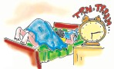

*What do you see in the pictures given below ? Discuss.*

I woke up this morning And I got into bed, Then I ate a cup of tea And drank a slice of b

**1. Hobble-Bobble**

I went to the bus stop

read,

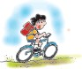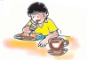

And caught the train to school, I rode my bicycle

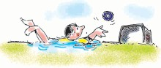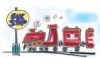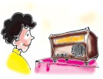

In the swimming pool.

Some one broke the telephone So then I rang my friend,



We went to the football field And swam from end to end.

I came here this evening And watched the radio,

I lay down on the ceiling And read a video.

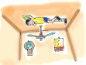

Oh! What a crazy day ! Oh! What a crazy day !

Word Meanings

slice a flat piece (of bread) cut from a larger piece or chunk ceiling the inner surface of the top part or the roof of a room. end to end from this side to that side of the field.

Reading Comprehension

1. **Make a list of the things the child does in a strange way. Example :**

‘ate a cup of tea.’

***English-7***

###### See the pictures carefully and write the lines from the poem under the related picture.

**watched the radio**

 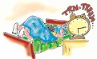

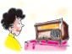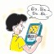

Vocabulary

**Give the correct words for the following underlined words/ phrases.**

**Example :** I woke and got into bed

I woke and got out of bed

1. ate a cup of tea
2. drank a slice of bread
3. caught the train to school
4. rode the bicycle in the swimming pool
5. swam from end to end of the field
6. watched the radio
7. read a video



***Assessment***



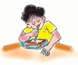

The Missing Whistle

**2. The Missing Whistle**

*What do you do when something is lost and you cannot find it ?*

After lunch, Piglet went to see Rabbit. "Come in !", Rabbit called.

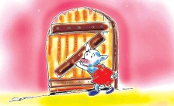

Piglet tried to go in, but he couldn't open the door.

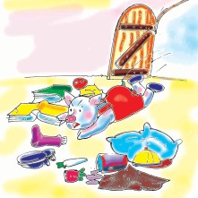

Rabbit was searching through a drawer.

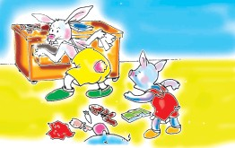

"I' ve lost my whistle, " he told Piglet. "I had it this

morning but I can't find it now !"

Piglet pushed and pushed. At last the door opened and he fell inside.

"What a mess !",

he said, looking around.

"I'll help you look for it," said Piglet. So, Piglet looked under the table and under the stool while Rabbit searched through the cupboards.

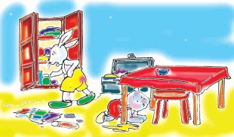

***English-7***

"Brother ! I can't find it anywhere !", grumbled Rabbit.

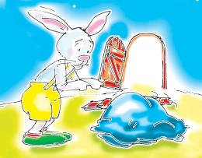

When he turned around he couldn't find Piglet, either !

*Do you know where Piglet is ?*

" Where are you ?", he asked.

"I'm here !", said Piglet, scrambling out of the pile of things Rabbit had thrown over him.

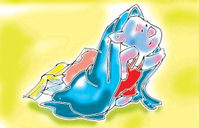

"I didn't find the whistle, "he said.

"Well, we'd better tidy up now and have some tea," said Rabbit.

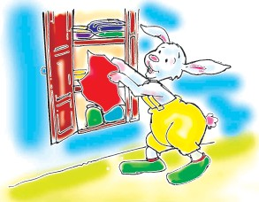

He picked everything up and put them in the cupboard–even Piglet !

*Did they find the whistle ?*

Rabbit fetched a bowl of *"Poha"* he'd made .

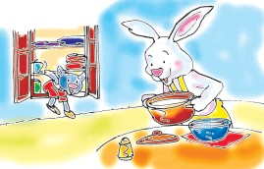

"That smells nice !", said Piglet, climbing out of the cupboard.

The Missing Whistle

Rabbit was eating the "*Poha*" when he bit on something hard.

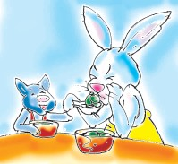

"My whistle !" he cried.

"It was hiding in the '*Poha*' all the time !" laughed Piglet.

***Word Meanings***

a young pig

things spread all around making the place untidy complained

coming out with difficulty

placing one on top of another, e.g. a pile of books clean, arrange neatly

brought

a loud shout

piglet

mess grumbled scrambling pile

tidy up fetched

cry

***Reading Comprehension***

###### Tick the correct answer.

* + 1. When Piglet could not open the door, he -
       1. knocked the door (b) pushed the door

(c) kicked the door (d) went back

* + 1. Piglet went to see the rabbit -
       1. before lunch (b) before breakfast

(c) after lunch (d) after dinner

* + 1. Rabbit lost his whistle -
       1. at night (b) in the evening

(c) at noon (d) in the morning

###### Which line in the lesson tells you that Piglet was lost in the pile of things?

* 1. **12 actions are given in the table.**
     1. **Put the actions in proper order according to the story.**

***English-7***

###### Who did what ? Put a tick mark in the boxes against the actions.

|  |  |  |  |  |
| --- | --- | --- | --- | --- |
|  | **Actions** | **Order** | **Rabbit** | **Piglet** |
| 1. | scrambled out of the pile of things |  |  |  |
| 2. | said he had lost his whistle |  |  |  |
| 3. | searched through the drawer |  |  |  |
| 4. | pushed the door open |  |  |  |
| 5. | grumbled that he couldn't find the whistle |  |  |  |
| 6. | said that he would help to look for it |  |  |  |
| 7. | searched under the table and under the stool |  |  |  |
| 8. | said the *poha* smelt nice. |  |  |  |
| 9. | picked everything up and put them in the  cupboard |  |  |  |
| 10. | said that the whistle was hiding in the *poha* |  |  |  |
| 11. | came to Rabbit's house | 1 |  | **** |
| 12. | found the whistle in the *poha* |  |  |  |

***Vocabulary***

**Two words are given. Put a () tick mark in the space provided if the words rhyme with each other and (X) cross mark if they don't:**

|  |  |  |  |
| --- | --- | --- | --- |
| **Example:** | night | kite | ( **** ) |
| 1. | cry | dry | ( ) |
| 2. | grumble | scramble | ( ) |
| 3. | lunch | bunch | ( ) |
| 4. | fetch | catch | ( ) |
| 5. | mess | guess | ( ) |
| 6. | file | fail | ( ) |



**6**



**3. Hand Care**

*" Hand Washing is the Corner Stone of Infection Control." Discuss.*

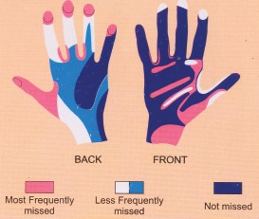

The results of a hand cleansing study established that in many cases, hand washing technique was inadequate.

**HAND WASH TECHNIQUE**

|  |  |  |
| --- | --- | --- |
|  |  |  |

1. 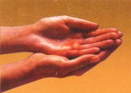Wet hands thoroughly with water. Take one measure of cleanser.
2. Rub hands palm to palm. 3. Right hand over back of left.

Change and repeat.

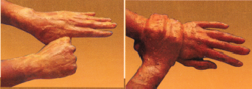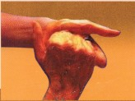

* 1. Fingers linked in palms.
  2. Rotate right hand around left

thumb, change hands and

* 1. Rotate right hand around left

wrist, change hands and re-

repeat.

Hand Care

**7**

peat. *- Poster*

***English-7***



### Word Meanings

very important

*"Sankraman",* being attacked by germs to stop, slow down

soap (a liquid form) to get rid of dirt

to prove with evidence way of doing something not good enough

turn around a fixed point completely

corner stone

infection control cleanser cleansing establish technique inadequate rotate thoroughly

***Reading Comprehension***

###### Write the sentence from the lesson that means "bad techniques of hand washing leads to infection".

1. **Look at the first picture and name the areas most frequently missed while washing hands.**
2. **There are six steps of hand washing in the advertisement. Which are the steps generally missed out by us ?**
3. **Complete the flow chart:**

How to wash hands :



Rub hands palm to palm

Hand Care



Change and repeat

### Vocabulary

###### Insert a, e, i, o, u in the bubbles to make meaningful words and write their meanings in your mother tongue.

cntrl

rtt

tchnqu

clnsng

ndqut

stblshd



thrghly

***English-7***

**4. Hard to Believe**

*Share some amazing facts with your classmates.*

One morning when Mummy was opening a new packet of detergent powder to wash Monty's dirty uniform, a small booklet



peeped out of it. Mummy handed it to Monty. Monty was very happy to see it. There was a puzzle which she had to solve. The company promised a mystery gift for children who would win the contest.

By evening, Monty had searched the answers for all the questions and the puzzle was worked out quite fast. Monty asked her Daddy to send it to the company's address. And it was sent.

Fifteen days later, Monty recieved her mystery gift–a beautiful little book.

It was full of interesting facts and pictures. Monty was excited.

That weekend Monty's headmistress announced a competition on 'Amazing Facts'. Each class had to make a presentation. The best three selections were then put on the school display board. Monty's selection was also there!

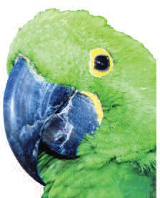

CONTESTANT - 1

**WINGED VICTORIES !**

A stolen parrot was brought to the court as a witness in New Delhi.

It could identify its real owner by repeating the names of her children !

In 1936, a hen was trapped in a crate when a violent storm destroyed the town of

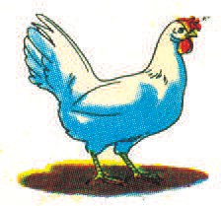

Gainesville, Georgia. Forty seven days later, it was rescued and it had survived by eating its own eggs.

Hard to Believe

CONTESTANT - 2

**MIRACLE MEN!**

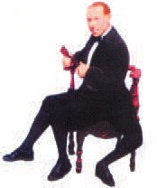

Francesco Lentini of Sicily, Italy, was a master musician.

He lived in the 1930s. He was a famous soccer player. He had three legs and that was a great advantage for him as a player.

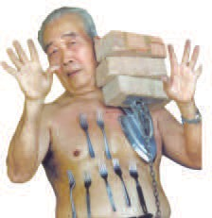

CONTESTANT - 3

**'THE MUDDY SCENE !'**

Liew Thow Lin of Gunung, Rapat,

Malaysia, can lift more than 60 pounds

of weight attatched to a metal plate against his chest or stomach. Lin is 71 years old and is called the Magnet Man. Nuts, bolts and tools can be seen dangling from his bare chest. In 2001, he pulled a car hooked to a chain attatched to a plate stuck to his chest. All the three sons of Lin and his two grand children also have the

magnetic ability.

Scottsdale, Arizona, organizes the Mighty Mud Mania festival every year. People sling mud on each other.

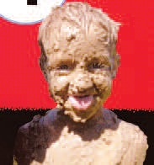

In the month of July, kids of all ages slip and slide over mud-filled tunnels.

More than 240,000 pounds

of mud is prepared for this event.

***English-7***

Elephants in Myanmar are very clever. They stuff the bells hanging around their necks with mud. They do this so that bells won't ring. They can then quickly steal bananas from farms at night.

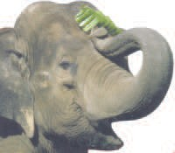Now,

Judge for yourself.

The best of these three is !!

### Word Meanings

***- Compiled by the writers' group***

detergent liquid or powder that contains soap for washing

to hand to give something to a person concerned or in authority contest a competition

display board a flannel board made for drawing and other presenta- tions

slide to move smoothly over a surface

ramps a slope that has been built to connect two places that are at different levels

soccer football

sling to throw something at someone from a distance stuff (v) to fill something tightly with soft material

witness one or many people in the court of law who tell what they saw or what they know about a crime or event

crate a box made of wood or plastic that is used for carrying fruits, bottles, etc.

survive stay alive

dangle to hang loosely or make something hang

### Reading Comprehension

Hard to Believe

###### Put a tick (  ) mark to choose the correct word or phrase to get a true statement.

* + 1. Mummy handed a booklet / a puzzle /a packet of detergent / to Monty.
    2. Monty's gift was a book of interesting facts / painted pictures / poems.
    3. One / two / three/ presentations were on the school display-board.
    4. The Mud-Mania festival is organized in the month of January / June / July.
    5. Elephants stuff their bells / trunks / necks with mud.
    6. The hen lived by eating grains / eggs / chicks.

###### Complete the information asked for in the table about the selections on the display board. Notice that each selection talks about two facts. One of them is done for you :

|  |  |  |  |
| --- | --- | --- | --- |
|  | **Who** | **What (festival / event)** | **Where (place)** |
| 1. | (a) |  |  |
|  | (b) |  |  |
| 2. | (a) |  | Gunung, Malaysia |
|  | (b) |  |  |
| 3. | (a) people | Mighty Mud Mania | Scottsdale, Arizona |
|  | (b) elephants | Stealing bananas |  |

* 1. **Look at the title of the selections on Monty's school display-board. Now answer the following questions.**
     1. Title : THE MUDDY SCENE

(a) Do you like it ? -------------------------------------

(b) What is common in the facts

under the title ? -------------------------------------

* + 1. Title : THE WINGED VICTORIES
       1. What does the word 'winged'

stand for ? -------------------------------------

(b) What were the victories? : (i) ----------------------------------

(ii) ---------------------------------

***English-7***

* + 1. Title : MIRACLE MEN

(a) Who are the miracle men ? -------------------------------------

-------------------------------------

(b) What is miraculous in them ? -------------------------------------

-------------------------------------

###### Mention the paragraph numbers which contain the following facts / ideas.

1. People of all ages slip and slide over mud in the month of July.
2. A large quantity of mud is required for the Mud-Mania festival.
3. Stuffed bells help elephants in stealing bananas.
4. No other bird could have known the names of a client's children.
5. If the hen had not eaten its eggs, it would have died.
6. The magnetic ability of Lin was passed on to the next generations.
7. Lentini played football.
8. Monty won a book of amazing facts as the mystery gift.

### Vocabulary

###### Given below are sentences that describe some actions. Choose the words from the box that match the descriptions and write them in the space provided.

slinged, stuffed, rescued, steal, dangled, stick

* 1. He always threw the keys to me from a distance.
  2. I used rough cotton and pieces of cloth to fill in the rabbit that mother stitched for me.
  3. No one had seen Bittu taking out sweets from the kitchen.
  4. The fire men saved two children from the top storey of the building on fire.
  5. It was easy to snatch at the chain of the watch that hanged out from grandpa's pocket.
  6. Do not paste advertisements on the walls of the school building.

Hard to Believe

###### Match the two columns to make compound words.

Column I Column II

mud field

forty filled

magnetic board

three seven

display mistress

head legged

railway powder

cassette station

quiz player

detergent contest

###### Give one word related to the following family of words that occur in the text. The first one is done for you.

|  |  |  |  |  |  |  |
| --- | --- | --- | --- | --- | --- | --- |
| (a) screw-drivers, hammer, saw | T | O | O | L | S |  |
| (b) witness, judge, client | C |  |  | R |  |
| (c) take away quietly without permission | S |  |  |  | L |
| (d) competition, prize, win |  |  | N |  |  | S |
| (e) name, house number, village | A |  | D |  |  | S |
| (f) soiled, dirty, rain | M |  |  |  | Y |  |

1. **Francesco Lentini lived in the 1930s (Ninteen thirtees). The period between 1930-1939 is called the 1930s. Now, complete the following information.**

(i) 1960-1969 — .............................

(ii) ............................. — 1990s

(iii) 1950–................... — 1950s

(iv) 1890–1899 — .............................

(v) 1840–................... — .............................

***English-7***

**5. Alice in Wonderland-II**



*[In Book-6, you've read that Alice dreamt of a strange land of animals. She fell into a rabbit hole and followed the rabbit to its dining hall.*

*There, she drank a liquid and became very small. After that. ]*

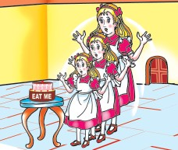Well, the next thing Alice found was a little cake; with the words 'EAT ME' marked on it. So, she sat there and ate it up. And then, guess what happened to her ! She grew and grew and grew. Taller than she was before! Taller than any child! Taller than any grown up person. Taller and taller! (Just look at the picture.) Which Alice would you like the best.

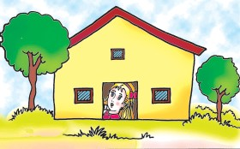A tiny Alice, no larger than a doll or a very tall Alice touching the ceiling of the roof ? Poor Alice!

What do you think ? Was she happy to find herself tall enough to reach the table and get the key to unlock the door or to be too small to get through the door? Well, she could

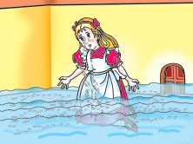do that; but do you think she could get out of that tiny door? She could only just manage to lie flat, put her head down on the floor and look out through the door.

Poor child! She sat down on the floor and wept bitterly. She wept and wept and

Alice in Wonderland-II

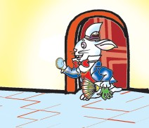wept. Her tears ran down like a river and very soon there was a large pool of tears in the room.

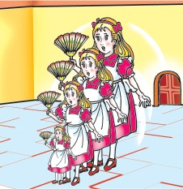Suddenly, the white rabbit entered the room. He was dressed up to go somewhere. He had a little fan and gloves in one hand and a watch in the other hand. He was looking at his watch, muttering to himself, "I am late,

Oh, I am

late!" He did not notice Alice. Alice requested him, "Please sir, "

The white rabbit was so frightened on hearing the voice, that he dropped his fan and gloves and ran away through the door.

Alice took a deep sigh, took up the fan, and began to fan herself. And lo!. What

happened ! With the movement of the fan she

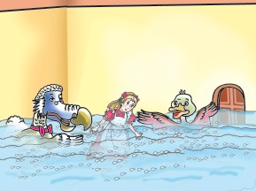got smaller and smaller and in a minute she was just about the size of a mouse. In the pool of tears, a mouse was

already swimming. Alice was also swimming with him.

*How did Alice become small ?*

They came out of the pool and both were wet. There were other creatures in that swimming pool like a dodo, a duck and an eaglet. Alice heard them talking about a party in the garden outside, and she

thought..... ***- abridged from Alice in Wonderland***

***English-7***

### Word Meanings

weep in a way shows one is very unhappy

to speak quietly or in a low voice usually when some one is annoyed

look

a piece of clothing used for hands

to breathe out making a long sound, especially when you are bored, disappointed, tired, etc.

a large bird that couldn't fly and doesn't exist now

a young eagle

bitterly

muttering

lo gloves sigh

dodo eaglet

***Reading Comprehension***

###### Put a cross (×) mark against the statements which are not true about Alice.

* 1. Alice did not eat the cake. ( )
  2. When Alice ate the cake, she grew taller. ( )
  3. The door of the room was too small for Alice to get out. ( )
  4. Alice talked to the white Rabbit and he helped her. ( )
  5. There was a pool in the hall. ( )
  6. The white Rabbit was going to give the fan and gloves ( ) to Alice. ( )
  7. Rabbit was dressed up to go somewhere. ( )

###### Write the names of all those who were swimming in the pool of tears.

............................. ............................. ............................. .............................

............................. ............................. ............................. .............................

Alice in Wonderland-II

###### Complete the table to tell what Alice could do in the Wonderland and what she could not. Select the phrases from the list given below.

|  |  |
| --- | --- |
| Could | Could not |
| eat the cake | get through the door |
|  |  |
|  |  |
|  |  |
|  |  |

unlock the door, look through the door outside, lie on the floor, touch the ceiling, swim in the pool of tears, get out through the door , grow tall, get smaller.



### Vocabulary

###### Find the words from the box that can complete the sentences correctly.

drank-up, grown-up, ate-up, torn-up, wake-up

1. Montu was naughty when he was a boy. He is a smart and .................

person now.

1. Meenu was very sad to find her drawing book when

she came home.

1. I always at 5 in the morning.
2. Ahmed's mother was happy because he all the milk.
3. I was very hungry and ........................ all the biscuits in the kitchen.

***English-7***



**6. Unity Is Strength**

*Can birds be stronger than man ? Discuss.*

Once a flock of doves flew far away from their home in search of food. Though they flew for miles and miles, they could

not find anything to eat. Tired and hungry, they were flying over a forest.

The smallest of the doves was so tired that he said to the Dove King, “O, King, please can we rest a bit?”

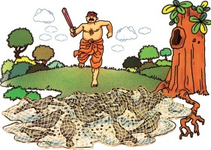“Oh, come, little one, be brave,” replied the king. “We are sure to find some food soon.”

So the little dove flapped his wings harder. He flew so fast that he found himself ahead of all the others. Soon he turned to them and said, “Come on, hurry up, I can see some food down there.”

The doves looked down, and

there they saw, some rice scattered on the ground just below a big banyan tree.

*Who had scattered rice on the ground?*

“Come, my friends, let us eat” said the Dove King. Together the doves landed under the banyan tree and began to eat the rice.

Suddenly, a vast net fell over them. The doves were trapped in it. “We are caught,” cried the king. “What shall we do now ?”

The next moment, they saw a big, fat hunter coming towards them. He was carrying a huge club.

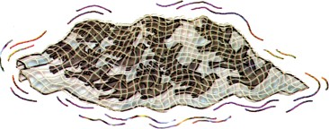“We must do something immediately, before the hunter kills us said the Dove King.”

All the doves were struggling to get out of the net. “How can we save ourselves?”,

they cried.

Unity is Strength

“I have an idea", said the king. “We must act together. We shall all fly up, carrying the net with us. Remember now, unity is our only hope.”

Each dove caught the net in its beak. Then all together, they flew up. The hunter was almost upon them when suddenly he saw his net going up into the air. He was amazed to see the unity among of the doves in their effort to get away. He ran after them, hoping that the net and all the doves would soon fall down. The doves saw him running after them. So they flew high over hills and valleys and went far, far away where the hunter could not follow them. At last, the hunter grew tired and gave up the chase.

*What will the doves do next ?*

When the Dove King saw that the hunter was no longer following them, he said, “Half our troubles are over. Now we must fly to the hill near the city of temples. There lives my faithful friend, a little mouse. He will certainly help us. He will cut the net with his teeth and set us free.”

“Yes, yes, let us go to the city of temples,” said all the doves in chorus and on they flew. Soon they reached the place where the mouse lived.

When the mouse heard the loud noise made by the flapping of wings, he was frightened and hid himself at the far end of his house. But the Dove King called out to him softly and said that he had come to ask for his help.

The mouse looked out. He was happy to see that it was his friend, the Dove King, who was talking to him.

“We have been caught in a trap set by a hunter,” said the Dove King. “We cannot get out of this net. When the hunter came, we flew together taking the net with us. Now, please help us. Cut the net with your teeth and set us free.”

“Very well, I shall set you free first.”

“No, no,” said the king. “Please free my followers first.”

The little mouse was wise. He understood the feelings of a king towards his subjects. So, he began to cut the rest of the net. One by one, all the doves were set free. And then, at last the Dove King was also set free.

All the doves were grateful to the little mouse for saving them. With a loud flapping of wings, they rose in the air and flew away.

***English-7***

### Word Meanings

a bird that looks like a pigeon

a net or equipment used to catch birds or animals catch

a stick thick at one end and used as weapon singing in a group

dove

trap (n) trap (v)

club chorus

***Reading Comprehension***

###### Complete the table and put the number according to the order of the events. One is done for you.

|  |  |  |
| --- | --- | --- |
| **Quotations** | **Order** | **Who said it?** |
| “We are caught. What shall we do now?” |  |  |
| “How can we save ourselves?” |  |  |
| “No, no please free my followers first.” |  |  |
| “O King please can we rest a bit,?" | 1 | smallest dove |
| “I have an idea. We shall all fly up,  carrying the net with us. ” |  |  |
| “Very well. I shall set you free first.” |  |  |
| “Come on, hurry up, I can see some food down  there.” |  |  |

***Vocabulary***

**Pickup the words from the text for the following expressions and write them against the expressions. (The number of letters in words is given in brackets.)**

1. noun form of strong (8) ......................................

2. spread over an area (9) ......................................

3. go after something (5) .......................................

4. with each other (8) ......................................

5. a huge tree with hanging roots (6) . ......................................

6. catches/ kills birds and animals (6) ......................................

7. used to catch birds (3) ......................................

8. not slow (4) ......................................

9. cats love to eat it (5) ......................................

10. you need it after a lot of work (4) ......................................

11. you need it when you are hungry (4) ......................................

12. a bird (4) ......................................

13. take someone’s life (4) ......................................

Jimmy Jet and his TV-Set

# 7. Jimmy Jet and His TV Set

*Who in your class watches TV the most? Find out.*

#### I'll tell you the story of Jimmy Jet And you know what I tell you is true. He loved to watch his TV set,

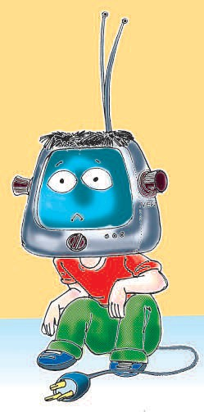Almost as much as you.

He watched all day, he watched all night Till he grew pale and lean.

From 'The Early Show' to 'The Late Late Show' And all the shows between.

He watched till his eyes were frozen wide, And his bottom grew into his chair

And his chin turned into a tuning dial, And antennae grew out of his hair.

And his brains turned into TV tubes, And his face to a TV screen,

And two knobs saying 'VERT' and 'HORIZ' Grew where his ears had been.

And he grew a plug that looked like a tail So we plugged in little Jim.

And now instead of him watching TV, We all sit around and watch him.

- Shel Silverstein

***English-7***

***Word Meanings***

(of Jimmy's face) having less than the usual amount of

colour very thin

a television programme still, not moving

the part of the body on which one sits

the front part of the face below the mouth

the part of a television that changes the signals into sound/pictures

wires or rod, put up, often on top of a house to receive television broadcasts

the picture tube(s) (of a TV set)

The poet has used plural forms of the words brain and tube]

round control buttons (for adjusting a TV set)

pale

lean show frozen bottom chin

tuning dial antennae tube(s)

knobs

***Reading Comprehension***

###### Answer the following questions.

* 1. What did Jimmy Jet want to do ?
  2. Why did Jim grow pale and lean ?
  3. What does the poet want to say in these lines:
     1. From 'The Early Show' to 'the Late Late Show.'
     2. He loved to watch his TV set as much as you.
     3. And now instead of him watching TV, we all sit around and watch him.
  4. What looked like a tail ?
  5. What message does this poem convey ?

Jimmy Jet and his TV-Set

###### Several funny things happened to Jim. Complete the table to mention the changes in him.

|  |  |
| --- | --- |
| chin |  |
| brains |  |
| face | TV screen |
| ears |  |
| bottom |  |
| hair |  |

***Vocabulary***



1. **Complete the word web.**

**Parts of a TV**

1. **Homonyms are words with same pronunciation but different spellings and meanings. Write the homonyms of the words given in the place provided.**

**Example :** see - sea

hair tail

- -------------------

- -------------------

pale - -------------------

ice to

- -------------------

- -------------------

###### The words given below have more than one meaning. Consult the dictionary and write the meanings of the words and frame sentences in your notebooks.

show, watch, antennae **25**

***English-7***

###### A word grid is given below :

**Find the rhyming words for the words given below. You can get the words both Horizantally and Vertically. Put a circle around the words :**

* 1. lean 2. jet 3. hair 4. pale

|  |  |  |  |  |  |  |  |  |  |
| --- | --- | --- | --- | --- | --- | --- | --- | --- | --- |
| m | b | e | a | n | k | e | e | n | l |
| e | b | e | t | w | e | e | n | a | e |
| t | a | i | l | g | e | t | e | i | a |
| m | e | a | n | n | p | r | t | l | n |
| s | h | a | r | e | l | c | a | i | r |
| p | e | t | a | l | e | i | g | y | m |
| b | s | a | i | l | d | a | r | e | s |
| e | s | a | l | e | e | s | a | l | e |
| e | s | e | t | t | s | e | e | n | m |
| n | f | a | i | l | n | f | a | r | e |

### Writing

###### There is a class of 100 students. Given below is a bar diagram showing what the students do in their free time. Look at the bar diagram and fill in the blanks.

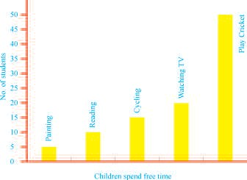

Jimmy Jet and his TV-Set

1. students paint during their free time.
2. As many as students play cricket in free time.
3. 10 students in their free time.
4. In their free time students do cycling.
5. Watching TV is a pastime for students.

### Activity

###### 1. Listen to the dialogue between Vishu and Vinni carefully. Encircle the TV channels that they watch.

*See Appendix 1,* Lesson 6.

Pogo, National Geographic, Cartoon Network, Doordarshan, Discovery, Zee TV, Aastha, Aaj Tak, Sanskar

###### 2. Listen carefully and complete the table.

|  |  |  |
| --- | --- | --- |
|  | Favourite channels | Reasons |
| Vinni |  |  |
| Vishu |  |  |
| Sheena |  | She doesn't understand anything.  She likes dance. |
| Vinni's grandmother |  |  |
| Vishu's parents |  |  |

1. **(Pair work) Give resons why we :**
   1. Should watch TV, 2. Should not watch TV.

*Project*

###### Collect at least two funny poems from any magazine or news paper.

***English-7***

**8. A Serious Talk**

*Name the pictures on this page.*

A spider sat quietly in the centre of its web. Suddenly,......................

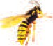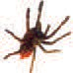

Ah, there is a swing in

the web again. I guess someone is in !

Oh God, again the

cobweb, I'm caught!

Good,

welcome fly dear, I was waiting for you

While this happened, a lady was cleaning her room. She sucked the spider,

the fly and the web all in to the vacuum cleaner.

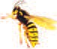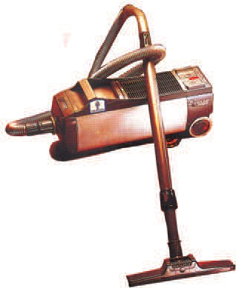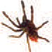

Eh, it's so dark (grgrgr.gr ). What's that

noise ? What's happening.

My head is whirling.

I'm falling. What is going on? Help! Help!

Vaccum Cleaner

A Serious Talk

By this time, the lady switched off the vacuum cleaner and everything became quiet.



Who's that ? I

can't see anyone.

Oh, are you Miss

Spider? I'm the fly you were going to eat a few minutes ago.



It's me, a poor spider. Who's there?

That's the rule. Spiders eat flies, birds eat spiders and cats eat birds.



It's so nice to hear

you. Are we going to die?

Ah, no, it can't be so.

I think we have been eaten up by something bigger than both of us.

I really feel sorry for

all the flies I've eaten. If I get out of here, I would be a different person.

I wish there was a world

where spiders and flies would be friends and insects would be free from fear!

I would like to drink

honey like butterflies. It wouldn't be a bad idea to learn to eat berries.

***English-7***





Oh, I was also thinking the same.

If I live longer, I would change myself too. I won't go to rubbish heaps and sit on rotten things. I wouldn't walk on any one's plate with dirty shoes on.



That's interesting! I don't

think we have ever had a chance to talk to each other and know each other's feelings like this before.

u...n....u....n.... But....

but it's too late, or else we could have changed the world.

*What will happen next ?*

In the meantime, someone took the bag of the vaccum-cleaner and emptied it on to the garbage heap. The spider got frightened. But, in a short while, he recovered. It stretched its legs and began making a new web.

Fly dear, are

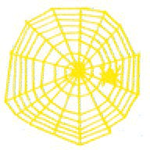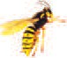

you here?

Look, I've made a beautiful and

peaceful new web. Do come and see it.

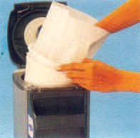Yes, Miss Spider are you there?

A Serious Talk





Boo..n...booh! This is where

you have to be Miss Spider. It looks just like the old one. I'm going. I can't,wait. We were friends but after all I'm a fly and you are a spider.

And the fly was ready to take off.

But where are you going?



To a new rubbish heap and then walk on someone's lunch with my dirty shoes.



But, fly dear, we are friends now. Do forget the past.



Ah, me ....... but I won't be again!

The fly rubbed its legs clean and flew off! And the spider sat and eagerly waited for an insect to get trapped into its web.

### Word Meanings

- Writers Group

cob web spider web, a net of sticky threads made by a spider to catch insects

Vacuum cleaner a machine that cleans floors by sucking up the dirt from them

garbage waste material, such as paper, empty containers and food thrown away

recover to get better after an illness, accident, shock, etc. rotten decayed

***English-7***

### Reading Comprehension

###### Use numbers to put the sentences in the order in which the events happened.

* 1. The vacuum cleaner sucked the spider and the fly.
  2. And the spider thought she was going to die.
  3. A fly was caught in a cobweb.
  4. The spider was inside the tube of the vacuum cleaner.
  5. The fly couldn't see the spider but he spoke to her.
  6. The spider asked for help.
  7. The spider's head was whirling.
  8. Then both the fly and the spider reached a soft surface, when the machine stopped.
  9. The spider felt sorry for all the flies she had eaten.
  10. Someone emptied the bag of the vacuum-cleaner on a garbage heap.
  11. The spider recovered from her fright.
  12. The fly went off in search of a new rubbish heap.
  13. The spider invited the fly to her new web.

###### What changes did the spider and the fly want to bring in themselves.

|  |  |  |
| --- | --- | --- |
|  | **TILL NOW** | **WHAT THEY PROMISE TO DO IN FUTURE** |
| Spider : | ate flies and insects | ........................................... |
|  | trapped in her web | ........................................... |
|  |  | ........................................... |

A Serious Talk

|  |  |  |
| --- | --- | --- |
| Fly : | sat on rubbish heaps | ........................................... |
|  | and thrown away food, and | ........................................... |
|  | walked on people's plates | ........................................... |
|  | with its dirty shoes |  |

###### Fill in the blanks with appropriate words :(a lady, pipe, bag, sucker)

1. The part of vacuum cleaner that sucked the cobweb was the

........................... .

1. The parts of the vacuum cleaner in which the spider and the fly were moving about was the ........................... .
2. The part of the vacuum cleaner that was emptied on the garbage was the ........................... .
3. The vacuum cleaner was operated by a ........................... .

### Vocabulary :

###### Write names of insects that can be trapped in the spider's web. Use the clues given below :





Clues : (a) A three-letter name and is very small.

* 1. It is green in colour, hops in fields.
  2. It bites you at night.
  3. It lives in the honey-hive.
  4. Sachin Tendulkar's game.

###### These are pictures of some movements. Can you name them? Use the clues in box below and also take the help of the dictionary.

***English-7***

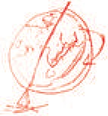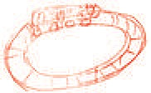

circling, revolving, spinning,

rotating, whirling, winding.

### Grammar

###### i Given below are some unreal situations. Now combine the other part as given in the example.

**Example:**

If I had legs (run away from

|  |
| --- |
|  |
|  |
|  |
|  |
|  |
|  |
|  |

the saucer) If I had legs, I would run away from the saucer

If I had a straw (drink the water)

If my hands whirled round (end up the day

and round. soon)

If I had roller skates (win every race)

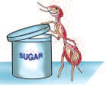If I had wings (invite Uncle Fox for a race)

If I could open the lid of the jar (finish all the

sugar in the jar)

If I had a stool (eat all the grapes)

A Serious Talk

### Activity

*See Appendix 1* Lesson 8.

###### Listen to your teacher carefully and fill in the details asked for.

Name : ......................

Insect : ......................

Total types : ......................

Body :

Legs : (a) number......................

(b) shape ......................

Wings : (a) number ......................

(b) shape ......................

Mouth parts : (a) shape ......................

(b) used for ......................

Home : ......................

Likings : ......................

Specialization : ......................

###### Before Pintoo went to sleep, he made a long list of things he had to do. Say what Pintoo was going to do at the market, next morning at home or in his friend's house and for whom.

**Example :** Pintoo was going to find last week's Sunday magazine for his grandpa.

|  |  |  |  |
| --- | --- | --- | --- |
|  | **At the market** | **Things to**  **do at home** | **In his friend's**  **house** |
| 1. | Get grandpa's glasses repaired. | Search last week's Sunday magazine. | Make a paper mask. |
| 2. | Bring betel leaf for grandma. | Pull out the old  carrom board from under the bed. |  |
| 3. |  | Search for the wooden horse from the store  room. | Make holes in a tin container to water  plants. |

***English-7***

|  |  |  |  |
| --- | --- | --- | --- |
| 4. | Buy a pair of small  scissors for himself. |  | Go to the river side  and collect shells with Chintoo. |
| 5. | Take clothes to the laundry. | Fill two buckets of water from the  tube well. | Pluck mangoes from the trees in  Chintoo's garden. |
| 6. |  | Put some (chana)  gram seeds in birdie's nest in the courtyard. |  |
| 7. |  | Cut pictures from old  newspaper |  |

### Writing

###### No one likes flies. If the fly wants to become a good insect, what would you suggest him to do. Write a small letter to him. You can take help from the lesson.

12 April 2005

G.P.S. Mohla. Rajnandgaon

Dear Fly,

I know you want people to like you. I feel people would like you if you ..................................................................

***Project***

**You all know that some animals eat some other animals or insects. So, they can never be friends.**

**Collect pictures of animals, birds and insects and paste them in front of each other. Also write their names.**

**Animal/bird that eats. The insect that is eaten**

...

.................................... ......................................

..................................... ......................................

**9. Have a Cup of Nice Tea**

*Do you know what Assam is famous for ? Yes ...... it is famous for tea. Name some other places where tea is grown.*

Have a Cup of Nice Tea

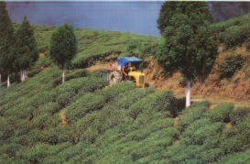

Tea is an evergreen shrub. The fermented, dried leaves are infused to make a beverage of the same name. It was seen in China as early as 2737

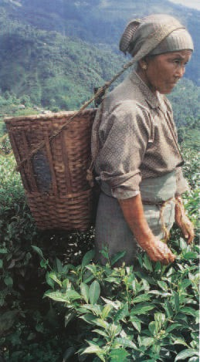B.C. Later in 1823 it was found growing wild in North India. It grows to a height of 12*"* to 40*"* . The young shoots and leaves are picked every 5 years. Once plucked, the young leaves are spread out for 4-15 hours. They are then broken up and dried and graded.

I am a tea shrub from the gardens of Kerala. I am 3 years old. My friends say I am very delicate, innocent, alert, always happy and beautiful. My height is 36*"* (approx). My parents told me that our relatives are present all over the world. Even though people all over the world make tea but the best manner of preparing tea is a subject of violent dispute.

*How do you prepare tea ?*

***English-7***

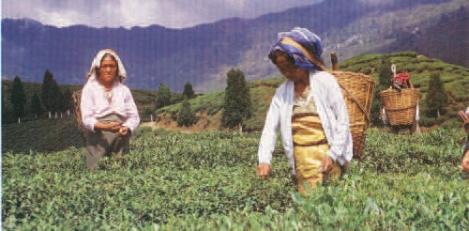

When I go through the cookery books for a perfect cup of tea, I find many ways of making it. Here are my own rules which I have deduced from the discussions with the elders of our family about tea and its preparation.

First of all, one should use Indian or Ceylonese tea. Now a days it is economical and one can drink it without milk but there is not much stimulation in it. Anyone who uses the comforting phrase "a cup of nice tea", means Indian tea.

Secondly, tea should be made strong. One cup of strong tea is better than twenty weak ones.

Thirdly, the tea should be taken in small quantites.

Fourthly, tea should be served hot. One should take the tea cups to the kettle and not the other way.'

Fifthly, after making tea, one should stir it, or better give the pot a good shake and allow the leaves to settle.

Lastly, one should drink out of a cylindrical cup.

Hope the next time you try to make tea, you would follow these golden rules.

- Writers' Group

Have a Cup of Nice Tea

### Word Meanings

low bush (smaller than tree) with several woody stems

*'Jhadi'*

to put in hot water so as to give the liquid the taste of substance.

a hot or cold liquid for drinking ( not water or medicine) quick to see and act

disagreement

to reach to facts by reasoning power to make one active shape of cylinder

bring to rest

shrub

infused

beverage alert dispute deduced stimulation cylindrical

settle

***Reading Comprehension***

###### Answer the following questions.

* 1. Who is 'I' in the lesson ?
  2. How is the beverage (tea) made ?
  3. The phrase 'A Cup of Nice Tea' is generally used for which tea ?
  4. What is the subject of violent dispute ?

###### Tick the correct answer.

* 1. The lesson is in the form of an autobiography because it is about :
     1. the tea .
     2. the shrub that talks about itself.
     3. the place.
     4. the country.
  2. The beverage (tea) is made from :
     1. young shoots or leaves
     2. young roots
     3. the fruits
     4. the seeds

***English-7***

###### Complete the flow chart to show how you make tea : Arrange the phrases in the box.

1. Put the bowl on stove.
2. Take a bowl with some water in it.
3. Add tea leaves.
4. Add Sugar.
5. Add milk.
6. Filter in a cup.
7. Leave the mixture to boil.

###### Imagine yourself as the tea shrub given in the passage and fill the bio- data:

Characteristics ................................................................

................................................................

................................................................

................................................................

Bio-Data

................................................................

................................................................

................................................................

................................................................

Name

Address Age Weight

Your views about the beverage (tea):

1. ------------------------------------------------------------

2. ------------------------------------------------------------

3. ------------------------------------------------------------

4. ------------------------------------------------------------

5. ------------------------------------------------------------

6. ------------------------------------------------------------

Have a Cup of Nice Tea

### Vocabulary

###### Complete the following webs by adding more words.

**Beverage**



**Shrubs**

* 1. **Read the riddles and try to find out the correct words.**
     1. I am a five letter word I am shorter than a tree I have 'rub' in me

I rhyme with tub What word am I ?

* + 1. I am a seven letter word. I rhyme with follow.

I mean 'not deep' I end with-low What word am I ?

***English-7***

* + 1. I am an eleven letter word My suffix is ... 'tion'

I start with 'sti'....

I have 'the power to make one active' What word am I ?

* + 1. I mean 'bring to rest'

I am a six letter word. I start with 'set'

What word am I ?

### Grammar

###### Given below are some clues in the block. Use these clues to frame sentences. Use who for persons, where for places and which/that for things.

|  |  |
| --- | --- |
| cobbler : | mends shoes. |
| hospital : | ill or wounded people are treated |
| pen-stand : | used for keeping pens |

**Example:**

1. A person who mends shoes is a cobbler.
2. A place where ill or wounded people are treated is a hospital.
3. A thing or container which is used to keep pens is a pen-stand. carpenter - makes and repairs wooden objects. water bottle - used for carrying drinking water. cinema hall - films are shown

post-office - stamps are bought, letters and parcels are sent tiffin-box - used for keeping light meal. (snacks)

police-station - a local office of police in a town or city where complaints can be made.

Have a Cup of Nice Tea

### Writing

bus-stand - buses stop for passengers to get in or out. bag - used for keeping things.

doctor - trained to treat people while they are ill. cup - used to drink tea, coffee, milk etc.

###### Given are some pictures. Write an autobiography imagining yourself to be one in the picture and write a small paragraph using the clues given in the box. The first is done for you.



Clues : fins, can swim, gills, breathe, through, gives, different colours, sometimes, scales too.

1.

FISH

I am a fish. I have fins and can swim. I have a tail. I breathe through my gills. I have scales too. I have different colours on my body.

2.

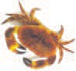

hard shells, eight legs, two claws, move side ways, not straight, catch food with claws.

CRAB

3.

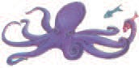

eight tentacles, catch food, rounded body, soft, smaller creatures for food.

|  |
| --- |
|  |
| biggest and most powerful fish, lives in sea, can eat human beings. |
|  |

4.



OCTOPUS

SHARK

***English-7***

### Activity

###### Listen to your teacher carefully and complete the table given below.

*See Appendix 1* Lesson 9.

###### Fill in the table :

|  |  |  |  |
| --- | --- | --- | --- |
|  | Students | Girls | Boys |
| Tea |  |  |  |
| Milk |  |  |  |
| Coffee |  |  |  |
| Lassi |  |  |  |
| Total |  |  |  |

How many girls are there in the class ? How many boys are there in the class ?

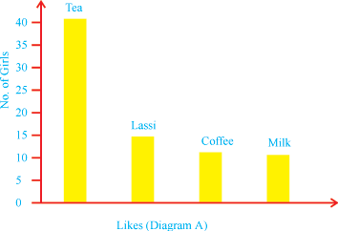

###### 2.

**Given above is diagram (A) showing the girls and their likes. Using the information in the table of activity 1, complete the bar diagram (B) as shown in 'A'.**

Have a Cup of Nice Tea

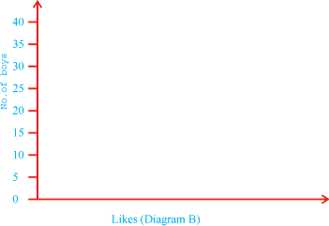

###### Say what would you like to be when you grow up (a doctor, a teacher, an actor, a singer etc.) Why ? (give 2 reasons). First, make a rough draft.

**Rough draft :**

Teacher at a nursery school reasons

* 1. Love children
  2. Like to teach, play with them

###### Completed example :

I would like to be a teacher in a nursery school because I love children and I like to teach and play with them.

### Project

###### Like tea, many other leaves are used in some way or the other in our daily life. Collect at least one leaf/shrub of some plants that are used raw (un cooked).

***English-7***

**10. Our Little River**

*Which is the river closest to your house ?*

Our little river twists and turns

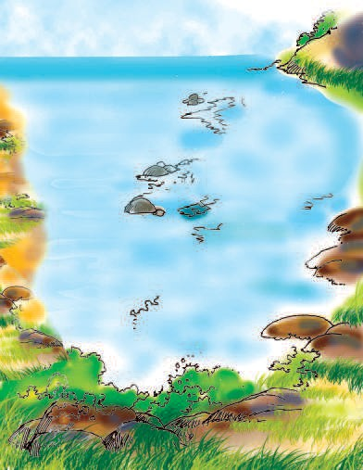

It’s just knee-deep when summer burns, How easy is it then to cross,

Cattle and carts just ford across,

The banks slope gently, though they’re high, And in the summer, always dry.

No dirt no mud : it all so clean,

The sand glints with a golden gleam, And to one side, there stands a bed

Of ‘Kash’, with white flowers overspread, Flocks of ‘mynahs’ gather there

And with their chatter fill the air, While deep at night the jackals prowl, Piercing the silence with their howl.

Groves of palm and mango trees Upon the other bank one sees, Nestling beneath their leafy shade The village houses stand arrayed, Along the bank the children play, Splash each other, duck and spray, Or sometimes, having had their bath, Catch small fish in bits of cloth,

The village women by that spot scrub with sand their pans and pots.

They wash their clothes and have their bath,

Then back they take the homeward path .

And then, often the rains begin The river fills upto the brim, It rushes then upon its course

In muddy whirls and deafening roars, Upon the banks, among the woods

A call rings out in joyful mood, And all the village wakes again To mark the festival of the rain.

### Word Meanings

Our Little River

change the direction

heat sparkling beam of light

creep around, lying in waiting penetrating something

trees in collective form resting

lined up (built in lines) to clear by rubbing completely full

path, way

turns

burns glints gleam prowl piercing groves nestling arrayed scrub

up to the brim course

### Reading Comprehension

###### Put the tick () against the right one and cross (x) against the wrong one.

|  |  |
| --- | --- |
| 1. The river is knee deep in summer. | ( ) |
| 2. It is not easy to cross the river in summer. | ( ) |
| 3. The river is straight. | ( ) |
| 4. The river is dirty. | ( ) |
| 5. Children play in the river. | ( ) |
| 6. The village houses are situated far away from the river. | ( ) |
| 7. The river fills it self up to the brim in summer. | ( ) |
| 8. They enjoy a festival in the rainy season. | ( ) |

1. **Answer the following questions.**
   1. How is the river ?
   2. Why is it easy to cross the river in summer ?
   3. Can the animals also cross the river in summer ?
   4. How do the river banks look like in summer ?
   5. Why does the sand glint and gleam ?
   6. Why do the jackals go there at night ?
   7. On which side of the river are the village houses situated ?
   8. In which season does the river fill upto the brim ?
   9. How does the river water look ?
   10. Why do the villagers have a joyful mood ?

***English-7***

### Vocabulary

###### 1. Go through the poem and make a list of describing words .

**2. Pick up the rhyming words from the poem for the following words and supply one word more for each.**

|  |  |  |  |  |
| --- | --- | --- | --- | --- |
| turns | cross | high | clean | bed |
| .......... | .......... | .......... | .......... | .......... |
| .......... | .......... | .......... | .......... | .......... |
| there | prowl | trees | shade | play |
| .......... | .......... | .......... | .......... | .......... |
| .......... | .......... | .......... | .......... | .......... |
| bath | spots | bath | course | again |
| .......... | .......... | .......... | .......... | .......... |
| .......... | .......... | .......... | .......... | .......... |

* + 1. **Use the following words in your own sentences**

burns, chatter, glints, catch, scrub, rings, mark

### Writing

###### Read the news extract about Advina Kant.

A girl from Korba, Chhattisgarh is the youngest child to have climbed one of

the tallest peaks, Gourlata, in Chhattisgarh. The mountain peak is 4018 ft above sea level.

**Given below are some more facts about Advina. With the help of these facts, write a small paragraph of 50-60 words on Advina.**

* + - 1. climbed on 11 May 2015
      2. age then was 5 year 10 months 03 days
      3. not her first attempt
      4. inspired by Bachendri Pal
      5. first attempt at the age of four
      6. her father Ram Kumar Kanth : a mountaineer.
      7. climbed with a team of seven mountaineers**.**

Our Little River

### Activity

###### 1. Some phrases are given below. Read them.

take bath early

in the morning

festival of Kerala

get up late

horse races

celebrated

in July

make colourful flower patterns

get up

early

wear

new clothes

celebrated in August or September

boat races

festival of Rajasthan

**Now listen to carefully to the passage. Put a tick mark in the boxes as you listen to these phrases.**

*See Appendix 1* Lesson 10.

###### 2. Listen to the passage carefully and complete the table.

|  |  |  |  |
| --- | --- | --- | --- |
| Festival ................................. | | | |
| C  E L E B R A T E D | When | |  |
| Where | |  |
| How | What people do? |  |
| What Girls do? |  |
| What is done on last day? |  |

***Project***

**Make your own paper boat.**

**11. Grandchildren by Surprise**

*Is there any old couple in your village who live alone; without children or grandchildern?*

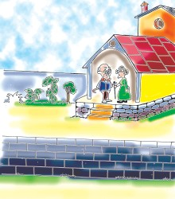Down the block at 1814 Beech Avenue lived Mr. and Mrs. Newton. She was short and round and neat. He was tall and thin and careful. Their house was as neat as a pin. Not even a shoe was out of place. Their meals were always on time. The neighbour’s children knew that they should keep off their grass. When they stepped on it, Mr. Newton did not like it.

***English-7***



The Newtons didn’t know much about children. But they did know that children make noise. They knew children are likely to mess up the house and spill things. The Newtons did not like anything to be messed or spilled. They liked everything to be just so.

*Did the Newtons like children ?*

The Newtons were busy doing things all day long. Together they knitted, baked, and built things. Mr. Newton made a tall clock that looked like a tree. It had a little bird that would fly out and sing sweetly. He made it all, and it was just right. Everything about the Newtons’ lives was quiet and careful and neat.

One afternoon the Newtons got a letter. Mrs. Newton opened it right away for they did not get many letters.

Madrid 30 September 03

Dear grandma and grandpapa,

Surprise! One of these days soon you are going to get a surprise! There will be a knock at the door. When you open it, there we will be–all of us!

Love and kisses.

Your grandchildren

“How can this be?” asked Mrs. Newton.

“We have no grandchildren. Somebody is playing a joke on us.”

Mr. Newton said, “It’s not a funny joke. When they knock, we just won’t answer the door. Children make a lot of noise and mess.”

The next morning Mrs. Newton got out her mixer.

“I’ll make some cookies for the grandchildren, if they come,” she said.

The days went by and they waited and they waited for a knock. No one came. Finally, Monday afternoon, Mr. Newton said, “May be we read the letter wrong.” He read it again. He looked at the letter a long, long time.

Grandchildren by Surprise

“We have made an awful mistake,” he said quietly. “This letter was for 1814 Birch Avenue. The grandchildren are not for us.”

They were both sad. It was very quiet in the little house.

Then one afternoon an idea came to Mr. Newton. He put an ad in the paper. The ad read:

**Wanted**

Grandchildren to borrow. Any size or age. Please come to 1814 Beech Avenue on Saturday morning at nine.

There were only five days before Saturday. The Newtons made toys and baked

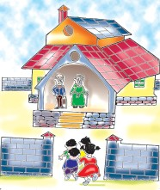more cookies. Finally it was Saturday. They waited and waited, but no one came. They waited all morning. They had worked so hard and hoped so hard. But no one came.

Mr. Newton went out into the yard. A little boy came by on his bike.

Mr. Newton said, “Hello there. What’s your name?” “Davey,” the boy answered. “My mom saw your

ad in the paper where you wanted to borrow some kids. She says no one would ask for kids when they could have a neat and quiet house.”

“Not us,” said Mr. Newton. “We have too much

quiet. Our house is too neat. We would like children to visit us. We have never had

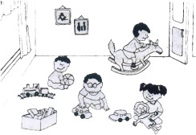any children. We would like to borrow some. Tell all your friends.”

“You mean it?” asked Davey.

“I really mean it!” said Mr. Newton. “I’ll tell them. I’ll ride all over.”

Almost before the Newtons knew it, there was a knock at the door. Children came!

*Why did Davey ask, "You mean it?"*

been hugged and welcomed.

Some looked happy. Some were very quiet. In a short time they had all

Then there was another knock, and more children were on the porch. “I am glad we made more cookies,” said Mrs. Newton.

Then more came, and more. Their house was full of children, of all sizes and ages! It was more than they had hoped for.

The ones who liked trucks and trains had trucks and trains to play with. The ones who liked dolls had dolls. They played with the doll-house. They were pleased

***English-7***

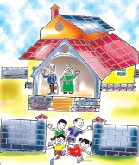that Mr. Newton had made all the dolls and toys for them. They had a wonderful time all afternoon.

The children left late in the afternoon. They promised to come back the next Saturday.

The neat little house was a mess. Even the clock went tock-tick. But Mrs. Newton looked very pleased. “Do you think there were enough toys and cookies for everybody?” she asked.

“There was enough of everything.” said Mr. Newton. “Toys and cookies and LOVE!”

***- Jane Flory***

***Word Meanings***

meals food eaten during breakfast, lunch, dinner

mess dirty or untidy condition

spill flow of liquid over the edge of a container

knit make woollen / cotton cloth

bake to cook in an oven without much oil or ghee (like biscuits) quiet silence

neat clean

surprise something that happens suddenly

joke something that you say or do to make people laugh borrow take something from someone for sometime and return it

later

yard a piece of land or empty space between a building and its boundary walls

porch verandah

hug to put arms around somebody and hold them tightly

keep off be away from

on time at the correct time out of place not in the right place

play a joke make someone angry or sad by doing funny things go by pass by

ad advertisement

cookies sweet biscuits

***Reading Comprehension***

**Answer the following questions.**

1. Read the letter given in the lesson carefully and answer the following questions.
   1. When was the letter written?
   2. Where was the letter sent from?

Grandchildren by Surprise

* 1. Who was the letter sent to?
  2. What was the main message in the letter?
  3. Who wrote the letter?

1. How was the address on the letter different from the address of the Newtons?
2. Do you find anything funny in the ad put in the newspaper? If yes, what is it?
3. What did the grandchildren play with?
4. Did the children enjoy the time they spent with the grandparents?
5. “Even the clock went tock-tick.”
   1. How do clocks go?
   2. Why does the writer say that the clock went tock-tick?
6. Name the things that the Newtons gave to the children.

***Vocabulary***

1. **Put the words given in the list of word-meanings in the order in which you find them in the dictionary.**
2. **Look at the difference in the two spellings of the word :**

Neighbor - neighbour

The first is American and the second is British.

**Now complete the table given below:**

|  |  |
| --- | --- |
| **American Spelling** | **British Spelling** |
| Neighbor | Neighbour |
| Color | Colour |
| -------------- | Favour |
| Labor | -------------- |
| Valor | -------------- |
| -------------- | Parlour |
| Vapor | -------------- |
| -------------- | Rumour |
| -------------- | Harbour |

1. **Use following phrases in your own sentences.**

out of place, play a joke on, come by, keep off

***English-7***

***Grammar***

**Work in pairs**

1. **Look at the flow chart carerfully. You will know how the paper is made:**

Use is/ are + V (III) form of the words given in the brackets and put them in the boxes. An example is given for you.

**Example: Paper from trees. (make)**

**is made**

At first the trees off their bark. (strip)

Then they to a pulp. (grind)

Then the pulp with chemicals. (cook)

Next it with water. (wash)

Next it Then it

. (bleach)

. (beat)

Then it with water. (mix)

And then it into one end of a paper making machine. (feed)

**Note:** We use the **‘passive voice’** when we are interested in an action, and not in the person responsible for the action.

**Active voice:**

Subject + Verb + Object Hari + writes + a letter.

Grandchildren by Surprise

**Passive voice:**

Object + Verb + (Subject) A letter is written.

In passive voice the sentence is made using

Object + is/are/am + V (III form)

1. **Pick out the words from the box and complete the statements given below.**

**One has been done for you :**

|  |  |  |
| --- | --- | --- |
| Use | as + adj + as | |
| neat - pin  cold - ice black - coal hot - fire white - milk blue - sky red - blood | |  |

Example: The room was as neat as a pin. His hands were as .......................................

His hair is as ..............................................

The kettle is as ............................................

Her teeth are as ...........................................

The water looks as ............................................

The colour of this rose is as .........................

***Writing***

**Look at the following notice in the ‘Lost and Found’ box of your school notice board:**

**Lost! Lost!**

07.03.04

Lost my lunch box. It is red. It is new. It has an oval shape.

One who finds it and returns it, will be given a treat.

Satish

Now write a notice for a newspaper about a dog you have lost. Take the help of the words given in the box:

fat white

black eyes with red collar long tail

***English-7***

***Activity***

1. **Listen to the passage carefully and complete the task given below:**

*See Appendix 1* Lesson 11.

(1) Name of the boy : ......................................

(2) At the age of two, he could name ........................................

(3) At the age of 9, he did ..........................................................

(4) At the age of 13, he was nominated for ...............................

1. **Make a list of your classmates who are afraid of the following insects, animals etc. Talk to each other.**

**Example : Are you afraid of ?**

Yes, I’m/No, I aren’t.

Now tell the class :

Most of my friends are afraid of .......................

A few students are afraid of Insects/animals Name of Students

a rat ................................................

a frog ................................................

a dog ................................................

a cockroach ................................................

a lizard ................................................

a snake ................................................

a spider ................................................

an ant ................................................

a mosquito ................................................

***Project***

**Imagine how Mr. and Mrs. Newton’s home looked neat and decorated before the children came in. They must have messed it up later. Collect the picture of a messed-up room and paste it in your note book. Show it to the class and say something about it.**

The Chinese–Our Neighbour

**12. The Chinese–Our Neighbour**

*What do you know about the Chinese? Share it with the class.*

Chang increased his pace as he walked along the river Lo. He was far away from his native village. From here he could not see the great wall, which was 2,400 kms long. It was built by the first Chinese Emperor, Chin Shih Huang Ti. The wall was stretched along the fertile river Huang Ho.

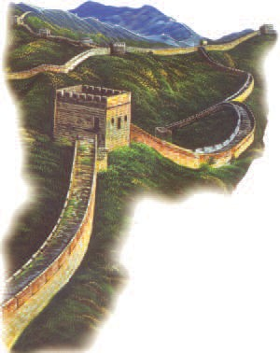

He was walking beside the river towards the city of Loyang. It was New Year and everyone was in a holiday mood. The rich people in their silk dresses and shoes, the peasants in their straw sandals, even the bare footed barbarians were happy. Chang felt his own dress and thought about the silk – the great invention of his forefathers.

The Emperor himself had taken part last week in ploughing a furrow to

begin the week-long celebration – the Festival of Lanterns. By the sunset, the whole town would be twinkling with little lamps lit inside a huge paper model of a dragon which would be carried along the street.

*Why was everyone happy ? Was Chang happy too ?*

Chang was now passing through the market place. Neat rows of stalls were selling all types of goods. The bronze utensils, iron tools, silk dresses, colourful paper toys, writing paper, wooden toys-so many things attracted him. The sound of music made him stop. Chang’s mind began to wander. So many wonderful things were happening. Ts’ai Lum had recently developed a new writing material called paper, using wood pulp and rags! It would be much cheaper than writing on silk. There were so many things Chang wanted to learn – mathematics, politics and calculations about the position of the stars. He wanted to be a mandarin. But it could be more exciting to be a trader, to travel along the silk road to Bactria or Persia one day, or even sail in a ship to foreign lands!

*What do we see when we pass through the market place?*

***English-7***

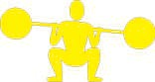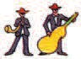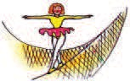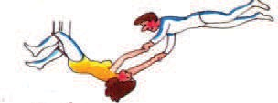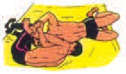

musicians

dancers

weightlifters

jugglers

wrestlers

acrobats

There were so many shows going on in the market place! There were jugglers, acrobats, wrestlers, weightlifters, dancers, musicians. the whole

place was buzzing with activity. Chang stood there and watched the wonderful sight. He felt a surge of pride and happiness. He was a part of this wonderful great civilization.

### Word Meanings

- Shri Amit Agarwal

to add

distant

to make something wide or long by pulling it rich land to produce more crops

farmers

footwear made of hay without foot wear uncivilized persons

to make something new

deep lines on soil in the field

a feeling of happiness, an event, or a festival

an imaginary animal that has a long tongue and looks like a dinosaur

roam about

happened only a short while ago soft, wet, part of a fruit or vegetable torn clothes

using numbers to find out some information or solve a problem

government officer

increase

far away stretch fertile peasants

straw sandals barefoot barbarians invention furrow celebration dragon

wander recent pulp rags

calculation

mandarin

The Chinese–Our Neighbour

trader businessman

exciting thrilling

sight scene

a surge of pride a sudden feeling of greatness

civilized the state of being gentle, well behaved pace speed

forefathers ancestors

plough (b) tilling and turning over the earth in fields

lantern a container (usually of glass) that encloses and protects the flame of a light

huge very large

attract to excite interest, feelings

recently not long ago

cheap low priced

juggler a person who can keep more than one objects in the air by throwing them up and catching them

acrobat a person skilled in walking on ropes, wires, walking on their hands

wrestle to fight by trying to hold or throw one’s opponent weight lifting the sport or exercise of lifting specially shaped weights buzz to make a continuous sound like that of a bee

sight view

### Reading Comprehension

###### Answer the following questions.

* + 1. Write the names of the two rivers mentioned in the lesson.
    2. Where was Chang going?
    3. What was happening in Loyang?
    4. What was carried along the street during the festival?
    5. What did the Emperor do at the beginning of the festival?
    6. What did Chang want to be?
    7. What shows were going on in the fair?
    8. Did Chang buy anything from the stalls?
    9. Why was Chang happy?

***English-7***

###### 1. Tick ( ) the correct sentences.

1. Chang lives in our age. ( )
2. Chang lived before the invention of silk. ( )
3. Chang lived before the invention of paper. ( )
4. Chang lived during the age when paper was invented. ( )

###### Write True or False against the statements.

* + 1. It was the festival of harvest. ( )
    2. It was the festival of lights. ( )
    3. It was the festival of lanterns. ( )
    4. It was the festival of New Year. ( )
    5. It was the festival of kite flying. ( )

###### Choose the correct answer.

1. The Great Wall of China is —————————.

|  |  |  |  |
| --- | --- | --- | --- |
| a. | 2,500 kms long | b. | 2,700 kms long |
| c. | 2,300 kms long | d. | 2,400 kms long |

1. The wall is stretched along the river ——————.
   1. Lo b. Huang Ho

c. Yellow river d. Si-Kiong

### Vocabulary

###### Add ‘-ion’ to the words given in column A and write them in column B. One is done for you.

|  |  |  |
| --- | --- | --- |
| **VERB** |  | **NOUN** |
| Calculate Celebrate Dictate Participate Vacate Narrate Operate  Locate | - ion | Calculation |

**Note:** A letter or a group of letters added to the end of a word is called SUFFIX. It is used to change the class of a word; like change of Verb to Noun. Suffixes do not change the meaning of a word.

The Chinese–Our Neighbour

###### Write the phrases as given in the examples using –ed, –en, –ing.

|  |  |  |
| --- | --- | --- |
| **–ed** | **–en** | **–ing** |
| Boil – rice | Earth – pots | Fly – kite |
| (Boiled – rice) | (Earthen – pots) | (Flying – kite) |
| Increase – price | Wood – furniture | Talk – bird |
| (—————) | (—————) | (—————) |
| Cook – food | Gold – ring | Weep – child |
| (—————) | (—————) | (—————) |
| Colour-pictures | Rot – apple | Love – mother |
| (—————) | (—————) | (—————) |

**Note: -ed, -en, -ing are used to frame describing words.**

1. **Fill in the blanks choosing the correct word from the box.**

increasing, stretch, inventions, fertile, utensils, civilization

* 1. Land which produces good crops has ————— soil.
  2. Prices of all the items are ———— now-a-days.
  3. Now-a-days we are using a lot of ————— made of steel.
  4. Modern age is called the age of ———————.
  5. We are a part of the great Indus valley —————.
  6. ————— a fence around this field.

###### D Match the columns.

|  |  |
| --- | --- |
| **A** | **B** |
| Mathematics | The science of the description of the earth |
| Civics  Geography Biology | The science of numbers The science of living things  The study of government and its business |
| Astronomy Botany History | The study of past events  The scientific study of stars and planets The science of plants |

***English-7***

### Grammar

###### Pick out the describing words from the lesson as given in the example. Write them in the columns as given below. Add some more.



|  |  |
| --- | --- |
| **Adjective + Noun** | **Noun + Adj + Noun** |
| Great wall | Week long celebration |

### Writing

###### A On the basis of the description of the fair in the text write about a fair visited by you based on the following points.

1. Place 4. Description
2. Month 5. Anything special
3. Reason 6. How you enjoyed it.

###### Fill in the blanks using the words given below.

carried, Dussehra, Bastar, dance, worship, decorated

* 1. Maa Danteshwari’s temple is ------------ for the festival of --.
  2. Maa Danteshwari’s Rath is -------------------- on this day.
  3. People from all over Chhattisgarh visit ------ to Maa Danteshwari.
  4. The people of Bastar wear new clothes and in groups.

### Activity

###### A 1. Listen to the description carefully. Match the pictures with their names.

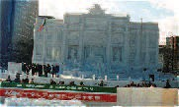*See Appendix 1,* Lesson12 Carnival

Snow festival

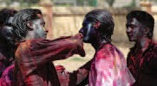The Chinese–Our Neighbour

Songkran

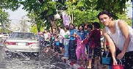Holi

###### 2. Listen and Complete the table.

|  |  |  |  |  |
| --- | --- | --- | --- | --- |
| S.No. | Festival | Country | Month | Special |
| 1. |  | Japan |  |  |
| 2. |  |  | February |  |
| 3. |  |  |  | People play with  colours |
| 4. |  |  | April |  |

1. **Use the table given to talk to your partner. You can ask questions using 'who', 'when' and 'where'.**

**Example:** Printing press was invented by Johannes Guttenberg in Germany in 1450.

|  |  |  |  |
| --- | --- | --- | --- |
| **Thing** | **Person** | **Place** | **Period** |
| Printing press | Johannes Guttenberg | Germany | 1450 |
| Thermometer | Galileo Galilee | Italy | 1593 |
| Steam engine | James Watt | Britain | 1784 |
| Type writer | Christopher Scholes | USA | 1872 |
| Sewing machine | Elias Howe | USA | 1845 |
| Telephone | Alexander Graham Bell | USA | 1876 |
| Television | John Logie Baird | Britain | 1926 |
| Digital Computer | Howard Aiken | USA | 1944 |

***English-7***

* 1. By whom was invented?

------------------ was invented by --.

2. Where was ----------------------- invented ?

------------------ was invented in --.

3. When was invented ?

----------------- was invented in --.

### Project

###### Make a ‘*Kandeel*’ with the help of the directions given below:

1. 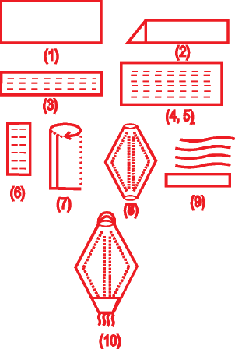Take a rectangular piece of paper.
2. Fold it into half along its length.
3. Draw lines as shown in the picture.
4. Cut along the dotted lines.
5. Fold the paper along the width.
6. Open the piece of paper.
7. Roll it up into a cylinder.
8. Paste along the length of the cylinder.
9. Paste some paper strips at the bottom.
10. Paste a paper hook at the top of the lantern.

Only God can Make a Tree

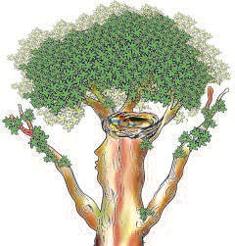

*Have you ever planted a sapling and seen it grow? If yes, share your exprience with your classmates.*

I think that I shall never see, A poem lovely as a tree.

A tree whose hungry mouth is prest, Against the earth’s sweet flowing breast. A tree that - looks at - God all day,

And lifts her leafy arms to pray. A tree that may in summer wear, A nest of robins in her hair.

Upon whose bosom snow has lain, Who intimately lives with rain.

Poems are made by fools like me, But only God can make a tree.

**13. Only God can Make a Tree**

### Word Meanings

- Joyce Kilmer

a small bird, (found in Europe)

chest

pressed ( poetic form in spelling ) very close, dear

spread

branches of a tree with leaves

robin

bosom prest intimate lain (v) leafy arms

***Reading Comprehension***

* 1. **Put a (  ) tick mark on the correct alternative.**
     1. Who is 'I' in the poem ?
        1. tree (b) women (c) poet (d) bird
     2. The tree is like -
        1. a mother (b) a child (c) God (d) The Earth
     3. The tree is fed by -
        1. another tree (b) Mother Earth (c) God (d) the Robin
     4. The Earth in the poem is compared to -
        1. God (b) a little girl (c) a mother (d) a tree
     5. The hair of the tree is its -
        1. stem (b) branches (c) flowers (d) roots

***English-7***

* 1. **Answer the following questions.**
     1. What does the tree wear during summer ?
     2. What part of the tree is referred to as its mouth ?
     3. How can the tree lift its arms to pray ?
     4. Which lines show that the tree is a female ?
     5. Who lives intimately with the tree ?
     6. What does the tree get from the earth’s sweet flowing breast ?
     7. What lay in the bosom of the tree ?

### Vocabulary

###### Find out the rhyming pairs of the words.

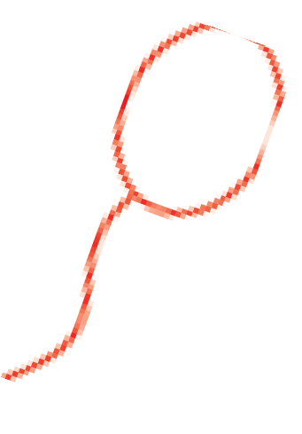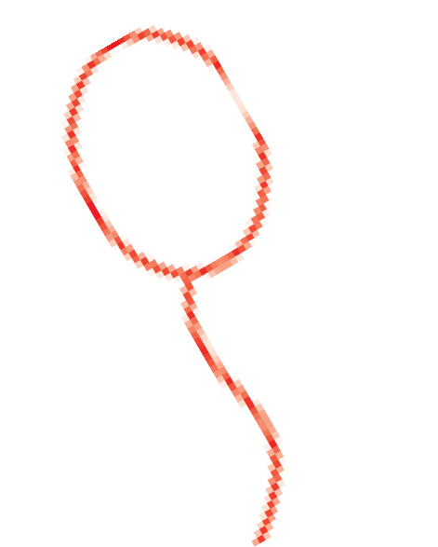

day

see

pray

tree

hair

wear

rain

lain

1. **Label the parts of the tree select your words from the list given in the box :**

Flower Root Branch

Bark Trunk Fruit

Leaf

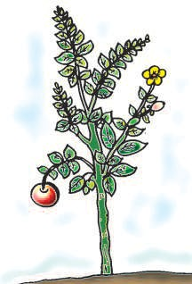

***Writing***

Only God can Make a Tree

###### Write a paragraph about your favourite tree. Take the help of the questions given.

* 1. Which is your favourite tree ?
  2. Where is it situated ?
  3. How do you care for it ?
  4. How is it useful to you ?

### Activity

###### Role play

**Ask a student to play the role of a tree. Other students will go to the tree and ask/request to cut, use, pluck, scratch the different parts of the tree.**

They can use sentences such as:

**Student 1 :** May I pluck your flowers ?

**Tree :** Yes, you may.

**Student 2 :** Shall I scratch my name on you ?

**Tree :** No please. It will hurt me.

### Project

###### Collect leaves of different plants. Paste them on a herbarium file.



**14. The Angel of Peace**

*Identify the person in the picture. What do you know about her ?*

It was Christmas time and there was a merry atmosphere all around. But the charity

***English-7***

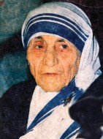

home which used to arrange Christmas party every year for the children, was passing through a state of crisis. It seemed that there would not be any party that year and the children would miss the special food on that occasion. Then suddenly a person came in and handed over an enve- lope to Mother. He said that Mother could use the money the way she liked. There were new hundred rupee notes in it and that year the children had the best Christmas party that they ever had.

This happened most of the times and at times when the door-bell did not ring, Mother was still able to collect money for that occasion. Her system of help- ing the poor was simplicity itself; she did what was possible. “She had no idea where the money would come from. But if a project was needed she would go ahead,” said one admirer.

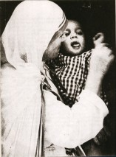

The Mother we are talking about, is none other than Mother Teresa, who is known as the *‘Lady of the Slums’, ‘The Angel of Mercy’, ‘The Saint of the Gut- ters’, ‘The Gentle Mother’* and other such names.

Her first major project – a home for the desti- tute, sick and dying, was opened in 1952 when she saw an old woman dying on the street, eaten by rats and ants. She picked her up, took her to the hospital and refused to move from there until she was admitted.

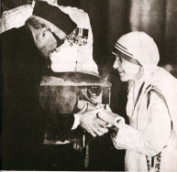

Then she went to the municipal authorities and asked for a shelter where the dying poor could die in dig- nity. She was provided a place near the Kali Temple Kolkata, and the following day she and her sisters and the dying- moved in. Today, some 150 people, many seriously ill and unacceptable elsewhere, are washed, fed and sheltered in this Kolkata home, called ‘Nirmal Hriday’.

The Angel of Peace

*Name some people in your area who help the poor.*

Returning to the streets of Kolkata, she began, collecting children to teach them hygiene. She sought a centre for her work. When a family offered rooms on the top floor of their large house, she appointed some assistants, eventually 26 in all, who formed the nucleus of the ‘Missionaries of Charity’. Now their number is more than 700 - mostly young Indians.

She lived a simple life, travelled by second-class on train, got down on hands and knees to scrub floors. She cherished simplicity and wore a shawl more darned than knitted. She saw in the poor what others often fail to see, their loneliness, their humour, their honesty and their courage.

“I am anxious for people to know of the greatness of the poor,” she said. She once went to a Hindu family which had been starving and brought them rice. Before she knew it, the mother of the family had divided it and given half of the rice to the muslim family next door. She said that they were just as hungry as her family was. “I believe we need the poor as much as they need us,” said Mother Teresa.

*How do you help your neighbours?*

The woman in the white sari with a blue border, Mother Teresa, till her death had no money, no property, no savings of her own. But her real wealth was Himalayan in size-7500 children in 60 schools, 9,60,000 patients cared for in 213 dispensaries; 4700 victims of leprosy in 54 clinics; 1600 abandoned or orphaned children in 20 homes and 3400 destitute or dying people in 23 homes, all this in 35 cities and towns in India and in a dozen other countries.

Today, even though she is not with us anymore, she is still loved by the poor and the neglected; respected by the Missionaries of Charity, admired by the Hindus, Muslims and Christians alike for her life long commitment to the poor that transcends all barriers.

### Word Meanings

state of cheerfulness, fun, happiness

difficulty, uncertainty

state of being plain, without pomp and show

a piece of work which needs effort, skill and planning one who thinks of someone with pleasure and respect an area of a city that is in a very bad condition

a messenger and servant of God kindness, pity, willingness to forgive ***sant, Mahatma***

bad social conditions of the lowest or poorest level of

society, canal filled with flow of dirty water

merry

crisis simplicity project admirer slum Angel mercy saint gutter

***English-7***

destitute having no money, no food and no shelter

Missionaries an organisation that collects money or food to help the of Charity poor and needy

dignity a state that makes one feel cared for and respected abandoned left alone

hygiene the study and practice of how to keep good health assistant helper

nucleus original or central point

cherish to love and care for somone / something darned a cloth/garment repaired by weaving threads loneliness state of being alone

humour funny, something that makes people laugh anxious worried

starving without food

Himalayan huge, great dispensary small health center

clinic part of a hospital where people come for special medical treatment

transcend to go beyond the limits

commitment a responsibility to follow a certain course of action

### Reading Comprehension

###### Answer the following questions.

* 1. How did the charity home celebrate Christmas every year ?
  2. What did the man hand over to the Mother. ?
  3. What does it mean by “ when the door-bell did not ring.” ?
  4. What did the admirer say ?
  5. What is ‘Nirmal Hriday’ ?
  6. What did Mother do on the streets of Kolkata ?
  7. How was the ‘Missionaries of Charity’ formed ?
  8. Find out words that describe Mother’s simplicity ?
  9. What did she want the people to know about the poor ?
  10. What was Mother Teresa’s real wealth ?
  11. How do people remember Mother Teresa ?

###### Write True or False for each of the sentences given below.

1. The children of charity-home used to enjoy Christmas party every year. ( )

The Angel of Peace

1. The envelope contained new thousand (1000) rupee notes. ( )
2. Many times the inmates of the charity home had no Christmas party.

( )

1. Mother knew from where the money would come for a project.

( )

1. The municipal authorities refused to provide her a place for the poor.

( )

1. Most of the members of ‘The Missionaries of Charity’ are Indians.

( )

1. Mother Teresa knew the greatness of the poor. ( )

### Vocabulary

###### Form sentences using the following words :

**crisis, project, dignity, hygiene, starving, property, hungry**

* 1. **Find out the words from the puzzle which come from the clues given below the puzzle.**

|  |  |  |  |  |  |  |  |  |  |
| --- | --- | --- | --- | --- | --- | --- | --- | --- | --- |
| s | m | s | t | r | e | e | t | a | k |
| m | e | r | c | y | d | j | g | p | c |
| s | h | e | l | t | e | r | p | u | h |
| b | c | t | p | k | s | p | o | t | a |
| s | l | u | m | s | t | i | m | t | r |
| d | o | k | c | e | i | s | a | e | i |
| w | y | c | t | i | t | a | i | r | t |
| c | h | i | l | d | u | i | z | c | y |
| d | i | g | n | i | t | y | e | c | k |
| p | o | o | r | g | e | t | n | t | p |

**Clues**

* + 1. road
    2. suffering from illness
    3. a place to live in
    4. one who is not rich
    5. kindness, pity
    6. ability to behave in a calm and respectable way
    7. son or daughter of a person
    8. having no money, no food and no shelter
    9. a house or an area of a city that is in a very bad condition
    10. to collect money or things to help the poor

***English-7***

### Grammar

###### Look at the following sentence.

Mother Teresa said, “ I am anxious for people to know of the greatness of the poor.”

In this sentence, the exact words of Mother Teresa are used and they are put in inverted commas.

We can also write the same sentence in a way that the same meaning is conveyed. We do so when we report someone’s

speech in our language.

**Example**: Mother Teresa said that she was anxious for people to know of the greatness of the poor.

###### Rewrite the following sentences as given in the example.

1. Mother Teresa said, “I believe we need the poor as much as they need us.”
2. She said, “They are just as hungry as we are.”
3. An admirer said, “She has no idea where the money will come from.”
4. Sister Franklin said. “This is a real sacrifice.”
5. Mother replied, “I love the people of Kolkata.”

### Writing

###### In this lesson we come to know about the service done to the society by Mother Teresa. Can you think of any other person who has served the society? Write a paragraph on the work of any such person/organization.

***Activity***

1. **Listen to the passage and fill in the following information about Mother Teresa.**

*See Appendix 1,* Lesson 14. First Name :

Her Date of birth :

Nationality :

Place of birth :

Occupation :

* 1. In the beginning
  2. Later

Awards received :

1. National

Award Year

The Angel of Peace

1. International

Award Year

Work Place:

Missionaries of Charity in other countries :

###### Look at the pictures of the great persons and say a few sentences about them.

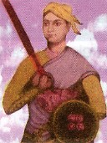

**Clues-** Father of the nation, Brave, queen, horse riding, non-violence, truth, fought Englishmen independence of India.

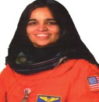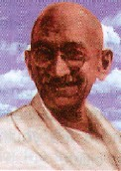

First woman space traveller, interesting features about the universe, wanted to use information from space for human welfare

### Project

###### Collect pictures of Mother Teresa and "Nirmal Hriday" and paste them in your note book.

**15. The Glorious Whitewasher**

*How do you get help when you have lot of work?*

***English-7***



It was Saturday morning and all the summer world was bright

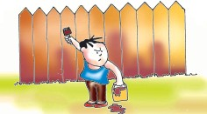

and fresh. There was a song in every heart. There was cheerfulness in every face and a spring in every step. The blossoms filled the air. Cardiff Hill was green with vegetation.

Tom appeared on the side wall with a bucket of whitewash and a long handed brush. He surveyed the fence and all gladness left him. It

was a thirty yards broad fence, nine feet high. Sighing, he dipped his brush and padded it along the topmost plank; did it again. After repeating the job two or three times he sat on a tree log.

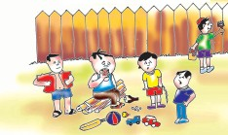

*Why did Tom sit on a log after repeating the job two ot three times?*

Jim came skipping out at the gate with a tin pail; he was going to bring water from the

town pump. Tom always hated this work to bring water from the town pump. He knew that Jim should come back after one or two hours. But Tom remembered that there was company at the pump. White and Negro boys and girls were always waiting their turns, resting, trading

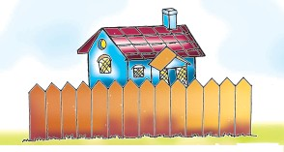

playthings, quarrelling and fighting.

Tom called Jim, “I will fetch the water if you will whitewash some.” “Oh! No,” said Jim.

“Jim, I’ll give you a marble, even, I will show you my sore toe.”

Jim was only human, this attraction was too much for him. He

put down his pail, took the marble and bent down to see the sore toe. But lo! In a moment Tom was flying in the street with his pail.

*What is meaning of 'flying' in the above sentence?*

Tom was whitewashing, showing all his happiness. Little Ben was making noise with his toy- ting-a-ling-ling-ting-a-ling-ling- ............. .

Tom paid no attention. Ben went up to Tom with the apple he was eating. Tom’s mouth watered for the apple. Ben said, “Hello! Hey! You are working.”

Tom : Oh! It is you. Did not notice; which work you said?

Ben : That work.

The Glorious Whitewasher

day?

Tom : Oh! That work, does a boy get a chance to whitewash a fence every

Ben : Let me do it.

Tom : No! No! It has to be done carefully. Ben : Oh! Oh! I want to try, only a little, Tom.

Tom : Jim wanted to do it, but I did not allow .....

Ben : Oh! I want a little, Tom, take my apple, I will do it carefully. Tom : Oh! Ok then, be careful.

He gave up the brush, took the apple, sat on the tree log, eating the apple

peacefully.

There was no lack of material; boys came, requested him to whitewash paying a lot of their treasure.

Tom sold the chance of whitewashing to Billy Fisher for a kite, Johny Miller for a dead rat and a string to swing it with. By afternoon, Tom had the treasure of twelve marbles, part of a harp, a piece of blue bottle to look through a glass, a key that would not unlock anything, a tin soldier, a couple of tadpoles, six firecrackers, a kitten with only one eye, a brass doorknob, a dog collar - but no dog, the handle of a knife, four pieces of orange peel and a dilapidated old window frame.

He had a nice company, idle time, and the fence had three coats of whitewash on it.

*The fence was whitewashed. Who did it?*

### Word Meanings

a person who is paid to work

deserving to be famous, praised happiness

jumping while walking cheerfully plants

to look at some thing carefully happy

a measure of length = 3 feet long narrow wooden board jump

to take in or out long deep breath exchanging

wound

run very fast

a state of not having something in bad condition

employee

glorious cheerfulness

spring in every step vegetation

survey glad yard plank skip sigh trading sore fly lack of

dilapidated

***English-7***

### Reading Comprehension

###### Answer the following questions.

* 1. What was the name of the town?
  2. What was the work allotted to Tom?
  3. Where was Jim going?
  4. Who were Tom’s friends?
  5. What attracted Jim?
  6. Make a list of five things collected by Tom from his friends.

###### Tick (  ) the correct and cross ( X ) the wrong one.

|  |  |
| --- | --- |
| 1. Tom wanted to whitewash the wall. | ( ) |
| 2. Tom wanted to play with his friends. | ( ) |
| 3. Jim helped him to whitewash the wall. | ( ) |
| 4. Jim ate the apple. | ( ) |
| 5. Billy Fisher had a kite. | ( ) |
| 6. Ben had a sore toe. | ( ) |
| 7. The fence had three coats of whitewash. | ( ) |

***Vocabulary***

1. **Pick out the things collected by Tom in the lesson. Write them down and complete the puzzle.**
   1. Young one of frog (7 letters)
   2. You can see through it (5 letters)
   3. A musical instrument ( 4 letters)
   4. It was a dead (3 letters)
   5. Not the oranges, but the (4 Letters)
   6. Window (5 Letters)
   7. It was a tin (7 Letters)
   8. Some dogs have it (6 Letters)
   9. He got twelve of it (7 Letters)

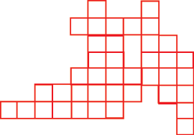

t1

h3

r4

p5

f 6

s7

c8

m9

g2

The Glorious Whitewasher

###### Match the words in column ‘A’ with their opposites in column ‘B’.

|  |  |
| --- | --- |
| **A** | **B** |
| like | neglect |
| happiness | forget |
| remember | dislike |
| notice | careless |
| careful | sorrow |

***Grammar***

1. **Make a list of describing words occuring in the lesson.**

Example: bright --------------- ---------------

--------------- --------------- ---------------

--------------- --------------- ---------------

###### Add - ‘ness’ to the adjectives to form ‘nouns’. Add some more words.

**Example:** glad + ness = gladness

happy, kind, polite, rich, good

###### Add - ‘ly’ to the adjectives to form ‘adverbs’. Add some more words.

**Example:** peaceful + ly = peacefully

careful, truthful, graceful, beautiful, faithful, cheerful

###### Work in pairs and practise the following dialogues.

**A B**

Do you like drinking milk? Yes, I do.

or

No, I don’t.

###### Now make similar dialogues using phrases given in the box.

listening to music

going on picnic eating sweets

reading the newspaper singing songs

playing football

1. **Using clues in the box, make sentences similar to the one given in the**

**example.**

**Example:** (drink-milk-tea)

I like drinking milk but I don’t like drinking tea. sing -old - folk songs.

***English-7***

go -zoo - museum

take -tea - coffee read -comics -stories like - music -dancing

###### Work in pairs and make sentences similar to the example:

Sarita wants to do many things. Sarita's teacher gave her advice. Make sentences as in the example given below.

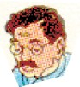**Example:** If you work hard, you will pass the examination.

work hard

play well run fast

take milk daily learn well

pass the examination

win the match win the race be healthy

stand first in class test



I want to

### Writing

If you---

###### Using the pictures given below complete the following story:

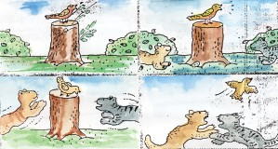

A -------------- was sitting on a stump of a -------------- . It was ------------

happily. Suddenly -------------- -------------- -------------- there. They saw the ........... ................. on the .................. They ................. on the

..................The away.

### Activity

###### Below is given a list of activities that people generally do in their free time, but what people like to do also depends on their age, job, ways of life and many other things. Listen to your teacher and write the name of the person against the activity that suits him/her. Before you decide, listen carefully to the details about the person.

*See Appendix 1,* Lesson 15.

The Glorious Whitewasher

watching movies reading books knitting

reading jokes

collecting shells

listening to classical music writing poetry

playing cricket

###### Work in pairs. Pick up the phrases from the box and ask your friend as given in the example.

**Example:** Would you help me? Yes, of course.

or

Sorry, I can’t.

help me

come with me give me your pen

clean the blackboard open the door arrange the benches come in time

make some tea shut the door

### Project

###### Try to do what Tom did to write the secret message.

Jim and Tom’s other friends got busy white-washing the fence. Tom had spare time. He wrote secret messages for Jim, Billy and Johnny. They were written on white paper but nothing was visible. Tom’s friends could see the message only when they went home.

1. Take a lemon and squeeze its juice into a bowl.
2. Wrap a piece of cotton at the end of a stick. Dip it into the juice and write the secret message on a piece of white paper.
3. Allow the paper to dry. Don’t place it near any source of heat.
4. When the ‘ink’ is completely dry, hold the paper near a burning lamp, candle or in front of a bulb. Don’t get too close, otherwise, it might catch fire. See if you can read the paper holding it against the sun.
5. Watch your message as it magically appears. Follow these steps and write a secret message for your friend.

***English-7***

**16. Halfway Down**

*What is your favourite place in your house?*

Halfway down the stairs Is a stair

where I sit. There isn't any other stair Quite like

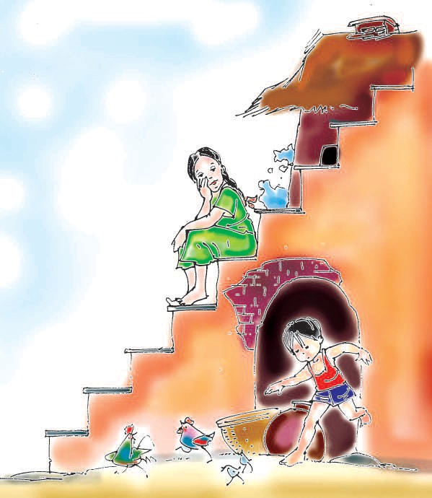

It.

I'm not at the bottom, I'm not at the top;

So this is the stair where

I always Stop.

Halfway up the stairs Isn't up,

Isn't down;

It isn't in the nursery, It isn't in the town.

And all sorts of funny thoughts Run round my head :

"It isn't really Anywhere Instead !"

A.A. Milne

**80**

Half–way Down

### Word Meanings

a flight of steps for passing one level to another

a child's play room things causing laughter idea

go through the head/ think

in the place of

stairs

nursery funny thought

run round my head

instead

***Reading Comprehension***

###### Answer the following questions.

1. What does 'I' refer to in the poem ?
2. Where does the child sit ?
3. Why does the child like to sit there ?
4. What is special about the stair where the child sits ?

### Vocabulary

###### Given are four sets of words. Each set makes a kangaroo word. The meaning of the kangaroo word is given in italics. Guess the kangaroo word. (Select all letters that occur in the sets. A letter might be repeated if needed.)



port,

up,

stop, pot, to,

top, pup

**Example :**

**Steps :** *to help*

letters - p, o, r, t, u, s, p

Kangaroo word - support

***English-7***

1.



neat, tin, eat, tea, sin, dine

*in the place of*

letters - -------------------------

Kangaroo word - -------------------------

2.



nurse, sun, yes, use, run

*a child play room*

letters - -------------------------

Kangaroo word - -------------------------

3.



stars, it, air, sat, sit, rat

*a flight of steps for passing one level to another*

letters - -------------------------

Kangaroo word - -------------------------

4.



out, ought, tot, thou, though, go

*idea*

letters - -------------------------

Kangaroo word - -------------------------

Half–way Down

###### Some words & pictures are given. Look at the pictures and give the rhyming words.

* 1. down



* 1. stair



* 1. head



### Activity

###### Listen to your teacher and identify the places being talked about.

*See Appendix 1,* Lesson 16.

|  |  |  |  |  |  |
| --- | --- | --- | --- | --- | --- |
| 1. | ....................... | 2. | ....................... | 3. | ....................... |
| 4. | ....................... | 5. | ....................... | 6. | ....................... |

###### Pair work.

**Look at the map carefully and give your friend the information about the questions that he asks. Word list can help you to ask the questions and answer the questions.**

near, right, left,

south, east, between, west, next to, middle, front,

**Your questions can be like these :**

* 1. Could you help me to find where the post office is.
  2. Excuse me, where is the post office?

###### Your answers can be like this :

1. ------- is to the right of the -- .

***English-7***

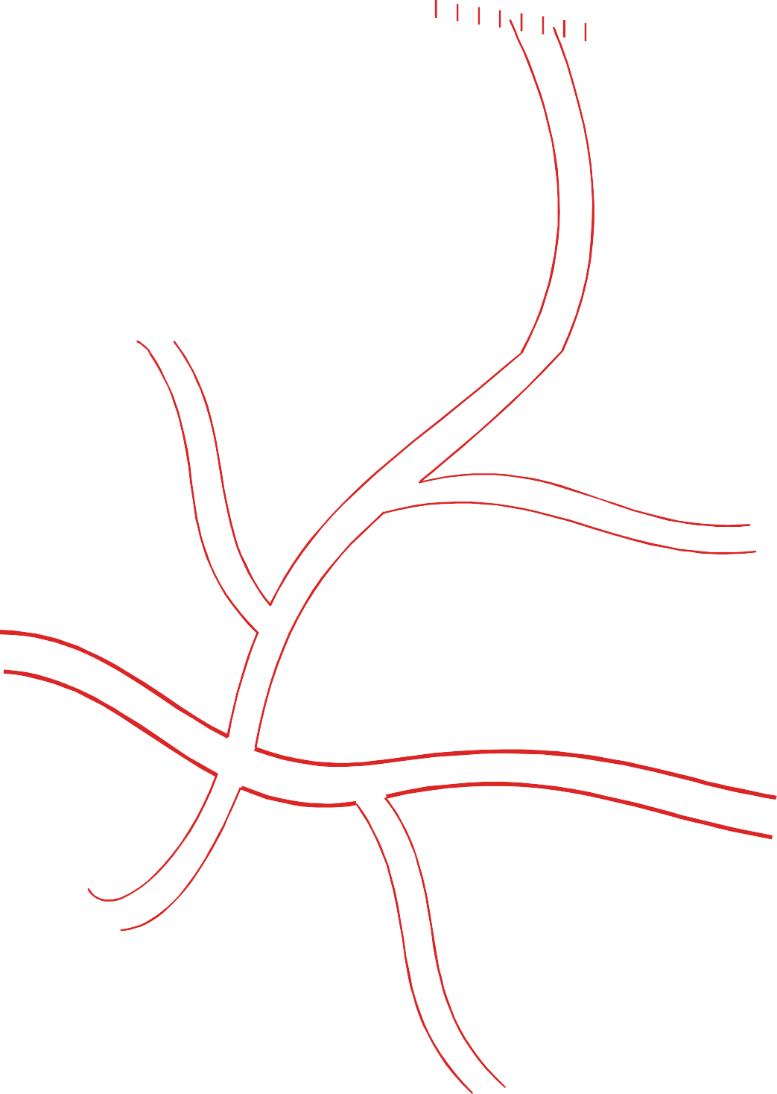

**Village Birpur**

N

W E

S

video hall

pond

Police Station

High School

market place

playground

Temple

Primary School

cinema hall

Post Office

School (Upper Primary)

hospital

Bus stand

highway

Library

mandi

S.T.D. Booth

Panchayat Bhavan

bank

Rail Route

Main Road

college

Highway

Half–way Down

### Project

###### Draw pictures or fix photographs of any five places near your village/town where you would love to sit in your free time. Write the name and place below the picture and why you would like it (one sentence). (Take help from the previous exercise word list.)

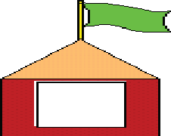

**Example:** Laxmi Narayan Temple

Near Post office Bijapur, (C.G.)

I like this place because it has a beautiful garden

.



***English-7***

# 17. Making Best Out of Waste, Her Forte



*What is your favourite pass-time?*

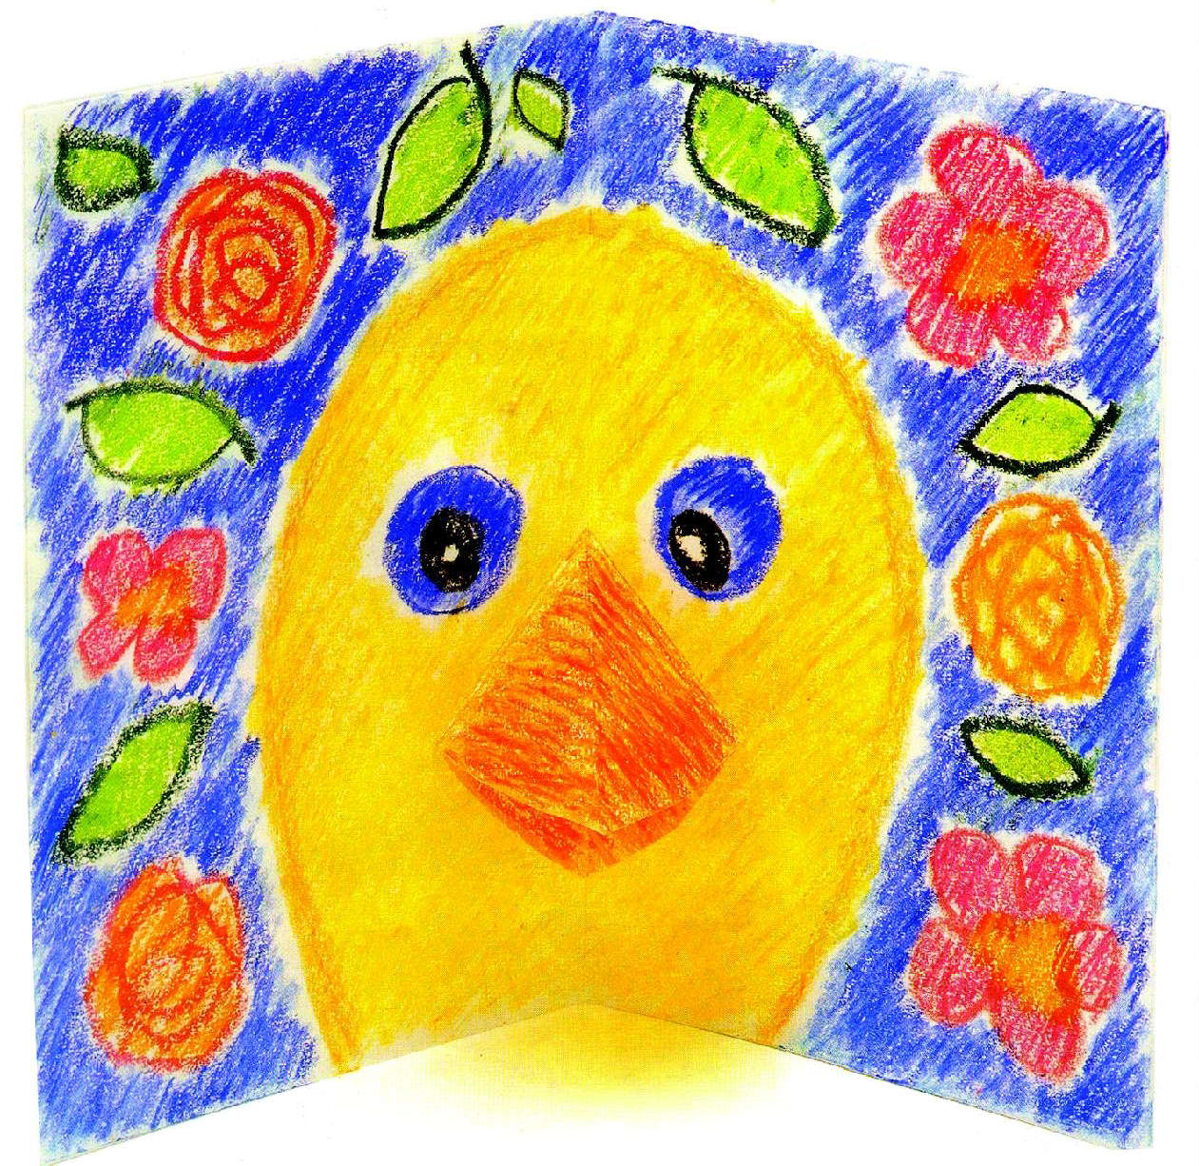Staff Reporter Bhilai, Sept-23, 03 The Hitvada

Rukmani Chaturvedi has got the art to make the best out of waste. Her masterpieces were shown to the Bhilains at a unique expo where she presented artworks made out of wastes like bhutta (maize) and banana- peels.

The Risali-based artist’s exhibition was inaugurated by the General Manager (Town Administration), R.K.Agrawal at Nehru Art Gallery the other day.

Utilizing maize, palm leaves and different parts of a banana tree, like its leaves, flowers etc, Rukmani created impressive paintings and collages. She has created artistic representations of Goddess Durga, Bhilai Steel Plant main gate, nature, historical figures like Jawaharlal Nehru and Subhash Chandra Bose among many others.

Without using paint, the collages were unique and subtly crafted. Ms. Rukmani has been successful in making her artistic creations come to life. Greatly impressed by the artistic skills of Rukmani, Mr. R.K.Agrawal expressed hope that the Expo will serve as an inspiration for budding artists of the steel city. Ms. Rukmani’s collection of 22 paintings was part of the joint exhibition of three women artists organized by Public Relations Department of Bhilai Steel Plant at Nehru Art Gallery. The other two artists, Ms. Kusum Lata Vaidya from Bhilai exhibited paintings made out of natural colours and watercolours. Charcoal and pencil was the creative medium for Ms. Rama Dutt Joshi of Raipur.

In all her 13 paintings Ms. Vaidya used environment friendly colours of human emotions and nature while Ms. Joshi’s 9 paintings depicted the life of locals. Mr. Agrawal commended their creative efforts and congratulated the organizers for bringing such unknown artists to limelight.

*What was the theme of the paintings?*

Present at the inaugural function were Chief Engineer, in charge (TA) Mr.K.K. Sharma, Chief Education Officer, Mr. R.C.Singh, internationally acclaimed Panthi exponent Devdas Banjare, eminent artist Das Gupta, senior officers of the Plant

and public. The exhibition ended on September 20.

***Word Meanings***

- Newspaper Item

special skill

things no longer wanted

forte waste

Making Best out of Waste, Her Forte

masterpiece a piece of work, which is the best of its type unique being the only one of its type

expo a big exhibition exhibition a public show of objects

inaugurate start with a ceremony, to declare it open impressive creating a strong or good effect

collage a picture made by sticking various materials on to a surface

create to produce something new

subtly cleverly

art skill

inspiration something which gives a person the ability to do a work

budding new and young

charcoal a black substance made by burning wood depict to show

gamut a whole range of presentation

commend appreciate, praise limelight centre of public attention

congratulate express pleasure or praise for a happy event acclaimed well known

utilize make use of

***Reading Comprehension***

###### Answer the following questions.

* 1. Who does ‘her’ refer to in the report?
  2. Where has this report been taken from?
  3. Which city was the Expo organized in?
  4. How many participants were there to exhibit the things?
  5. What major differences do you find between the paintings used by Rukmani, Kusum Lata Vaidya and Rama Dutta Joshi?
  6. When did the exhibition end? When do you think it started?
  7. Who inaugurated the exhibition?
  8. What could be the main outcome of such an exhibition, according to Mr. Agrawal?

###### Make a list of the things the participants exhibited:

Ms. Rukmani

Ms. Kusum Lata Vaidya

Ms. Rama Dutt Joshi

***English-7***

###### Make a list of the materials the artists used for their creation:

**Materials used**

**Names**

***Vocabulary***

###### Make sentences by using the table below.

|  |  |  |  |
| --- | --- | --- | --- |
| 1. | The prime minister | unique | for any one who wants to do social service. |
| 2. | Mother Teresa’s name  is an | budding | opportunity for Ms.  Rukhmani. |
| 3. | The Expo was an | inaugurated | artists. |
| 4. | Most of the people  still use | depicted | the winners of different  categories. |
| 5. | Every possible  opportunity should be given to the | inspiration | the seminar on energy  conservation. |
| 6. | The Chief guest | charcoal | the life of locals. |
| 7. | Ms. Joshi’s paintings | congratulated | as a fuel. |

* 1. **Match the words with their meanings. A B**

forte well known

masterpieces a big exhibition

exhibition special skill

collages cleverly

unique new and young

expo centre of public attention

acclaimed the best work of its type

budding appreciate

exponent a public show of objects

limelight a picture made by sticking various materials

subtly only one of its type

commend a person who sets examples for others

Making Best out of Waste, Her Forte

###### Fill in the blanks choosing appropriate words given below.

flowers, nine, Panthi, Rama, artists, forty-four

Mr. R.K.Agrawal inaugurated the exhibition. It contained the work of three

_ namely Rukmani Chaturvedi, Kusum Lata Vaidya

and

____________ Dutt Joshi. In all, there were

_______________

paintings. Of these only _ belonged to Ms. Joshi. Rukmani Chaturvedi used things like leaves, etc. to make her collages. Internationally acclaimed _ exponent Devdas Banjare was present at the inaugural function.

***Grammar***

###### Use the appropriate form of verbs given in brackets in the sentences given below.

* 1. She _ artworks made out of waste. (present)
  2. The Chief Minister the fast food shop “Star One” in Raipur recently. (inaugurate)
  3. God _ the world. (create)
  4. Sania Mirza the honour of entering in the Australian Open. (achieve)
  5. The programme was by the college. (organize)
  6. Paintings of local artists were (exhibit)

_________ __ in the auditorium.

* 1. The President _ the winners. (congratulate)
  2. The wind _ the letter out of my hand. (blow)
  3. He _ his hand while playing cricket. (break)

###### After the exhibition Rukmani had the following advantages:

1. People bought her collages. (iv) Bhilaians appreciated her art.
2. The television programme made(v) The management selected her her the talk of the town. for the state award.
3. People overwhelmed her by (vi) Many people contacted her for their response. guidance.

###### Now rewrite the sentences as shown:

(First sentence is given for you).

* 1. Her collages were bought by people.

2.

3.

4.

5.

6.

***English-7***

###### Make a list of all the verbs in the past tense occuring in the lesson.

***Writing***

1. **Read the following paragraphs carefully. There are two stories mixed up. Arrange the paragraphs in order to find out the stories:**

A mango tree said to a bush growing in its shade, “You are useless. No body wants you. I am used for roofs and houses everywhere. Men can’t do without me”.

The young deer was filled with fear and forgetting his resolve, took to his heels, along with his mother.

“Here is a man coming to you with an axe, right now. Farewell”.

A young deer said to his mother, “I am larger than a dog and swifter and I have horns to defend myself. When dogs appear I will run away with the others. I have decided not to run from dogs in future”.

“You are so right", said the bush. Just then they heard the bark of dogs.

###### Look at the pictures given below and write the related headlines under each picture given in the box.

* 1. Cute Cats at Home 2. Sleeping Ostrich

3. Run to Win 4. Friends Forever

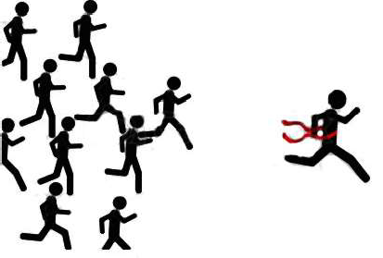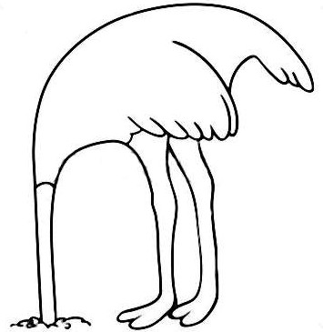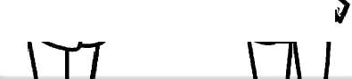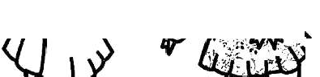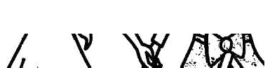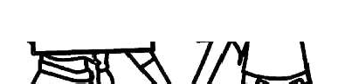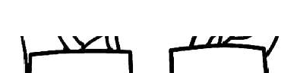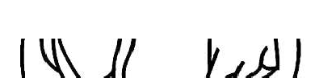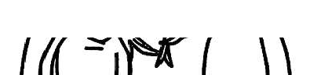

*Best Pals*

###### Punctuate the following passage with [capital letter, comma ( , ) question mark ( ? ) inverted commas ( “ ” ) full stop ( . ) exclamatory mark ( ! ) etc.

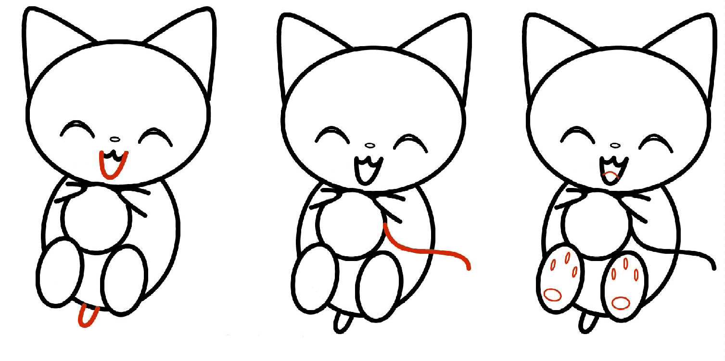

it was dreadful for the poor little duckling to live alone in the cold winter

come here duckling it is cold out there called a field mouse his hole was warm and cosy and was full of food he told her spring will bring better luck.

Making Best out of Waste, Her Forte

the duckling saw his reflection in the cold water and was so surprised what a beautiful swan was he have you ever seen a duckling changed into a swan.

***Activity***

###### Listen to the instructions carefully to create your own collage.

*See Appendix 1* Lesson 17 Things you need

* 1. Colourful wool yarn (in small pieces, at least four colours - blue, red, green, yellow)
  2. gum
  3. a white paper sheet
  4. colourful waste paper.

###### Arrange the students in pairs and ask them what they would say in the following situations. Write your sentences and speak in pairs.

**You are searching for your lost pen/ pencil.**

Ravi: Oh! _ Mohan: May I help you?

Ravi: _ Mohan: What colour was it ?

Ravi: _ Mohan: When did you lose it?

Ravi: _ Mohan: Were you in the library?

Ravi: _ Mohan: Is this your pen? Ravi: Oh yes! Thank you.

***Project***

###### Make a collage of your own with beads/paper bits/and leaves and show to your friends.

***English-7***



*Why should we write diaries? Discuss.*

Last month Asha visited a lot of places with her parents.

Here is a description in her diary. You would enjoy it......

*27th June 04* A very bad morning for me, for I had to get up very early. Mummy and Daddy didn't sleep all through. They were packing bags and making arrangements for our journey. But today I felt they are very partial. They never wake up Babloo, my three years old brother. They say he will mess up

things.

We started for Jagdalpur at 7 o'clock in the morning. We were going to my Dadi Ma's house. In the train I slept for 2-3 hours. Both Babloo and I had a lot of fun. We ate, drank, sang, played and did everything we could. Babloo made sure that mummy wouldn't take rest. We had our dinner in the train.

**18. Dear Diary.....**

*29th June 04*

Oh! what the an experience it was of sleeping in the train. I felt as if I was sleeping in a swing. Early in the morning at 6 o'clock our train reached Jagdalpur. Anup uncle and Tina aunty had come to the railway station to recieve us. Dadi Ma was waiting for us at home. We took some rest. I went with my uncle to the market. Babloo was busy with Dadi Ma.

In the evening at about 7 o'clock we went to visit the Chitrakut Waterfall. We reached there at 7:30. The waterfall was looking beautiful. The effect of lights added to its beauty. Babloo was the happiest person in the world. He was singing and clapping and was not ready to come back. We returned at 10 o' clock and had our dinner.

*How many members are there in Asha's family ?*

30th June 04

I had to get up early in the morning. But later on I enjoyed the day. Dadi Ma made my favourite *'Aloo paratha'*.

In the morning at 9 o'clock we started for Kanger valley National Park. We took a taxi. My uncle made arrangements to cook food there. In the National Park, we saw many wild animals and birds in their natural surroundings like Cheetah, Neelgai, Deer, Wild pigeons and Peacocks etc. After lunch we took rest and played hide and seek, badminton, antakshari and many more games. We also danced to tunes of film songs. We took a guide from Kutumsar Naka (check post). We saw the Kutumsar caves. As we en-

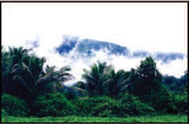Dear Diary....

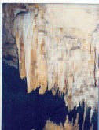

tered the caves, Babloo started crying as it was very dark there. He lost his sandals there. The huge 'Shivling' and the world famous blind fishes in Shankar kund are the attractions for the tourists. We also saw the *'Apsara Vihar'*. Babloo was the busiest person running here and there without sandals. All the time he was holding my frock and saying *"Didi humme bhi khilaona unn....."*. On our way back we enjoyed icecream. I want to sleep .....

*What are the places that Asha visited during her stay in Jagdalpur?*

|  |  |  |
| --- | --- | --- |
| *1st July, 04* | | |
| All of us woke up in the morning. After  taking bath we started for Dantewada. We enjoyed our journey very much as on both the sides of roads there were big trees, beautiful hills of Bailadilla and the Bastar | |  |
|  | tribes in their  traditional costume added |
| the natural beauty of that region. The climate was  also cold and pleasant.  The Danteshwari Maa's temple is situated where the two rivers Shankani and Dankani meet. There are three buildings in the temple— the Natya Mandal, the Sabha Griha and the Garbha Griha.  After offering our prayers we returned to Jagdalpur. All of us, Anup uncle, Aunty, Dadima, Subhash uncle, Swati (5 years) and Shanu (7 years)  enjoyed the journey in a van. Really, we enjoyed a lot. | |
|  | | |
| *4th July, 04*  In the morning we reached our Munni Mousie's house at Dongargarh. All through the way I slept in the van. They have a beautiful garden in their house. In the garden, there is a swing and a pond. Akshat, Munni Mousie's son and Babloo became friends. They spent the whole day in the garden swinging and watching the fishes in the pond. | | |
|  | | |
| *How did the family go to Dongargarh?* | | |

***English-7***

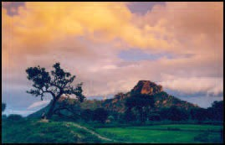

*5th July, 04*

In the morning again, we got up early and went to offer our prayers to Bamleshwari Maai. There are 1000 steps. There is one more temple at the foot of the hill. It is called Chhoti Bamleshwari Ma. After the 'Darshan' at 9 o'clock we returned from the temple.

In the afternoon we went to Durg to our Nani Ma's house. During dinner all of us sat together. Babloo also wanted a plate. He went to kitchen and brought a plate for himself. After dinner we all sat together and talked for a long time. Babloo fell asleep while he was in Nanima's lap listening to every- body. I was very happy today.

### Word Meanings

- Writers Group

unfair support

'*Jalprapat*'

an area of natural interest kept and protected by the government.

"*Luka Chipee*"or "*Chuppa-Chipee*" (a game) making one feel happy.

'*Jhula*'

small area of still water (not natural) pray to God.

partial

waterfall national park

hide and seek pleasant swing

pond

offer prayers

***Reading Comprehension***

1. **Read the diary carefully and make notes.**

|  |  |  |
| --- | --- | --- |
| **Where** | **How** | **What** |

1. **Answer the following questions.**
   1. Give the names of children mentioned in the diary.
   2. Which place do you think Babloo liked most?
   3. What was there in the garden of Munni Mousie?
   4. Pick out from the lesson three qualties to describe Babloo's nature.
   5. Why did Asha feel that her parents were partial?

Dear Diary....

### Vocabulary

###### Make a word list related to the given word.

Journey

1. **Use the following words in your own sentences.**

arrangements, frightened, drive, partial, surrounding

###### Complete the puzzle. One is done for you.

10



7

9

1

8

2

11

3

4

12

5

6

N

E

D

R

A

G

###### Clues

* 1. Brindavan (6 letters)
  2. Place of worship for Christians (6 letters) 3. Chitrakut (9 letters)

1. Kanger Valley National (4 letters)
2. Muslims worship here. (6 letters)
3. Kutumsar (4 letters).
4. Red (4 letters)

8. Bailadilla................. (4 letters)

1. Sikhs worship here (9 letters)
2. English term for Ghati (6 letters)
3. Hindus worship here (6 letters)
4. Large area of water surrounded by land starting with L (4 letters)

***English-7***

### Grammar

###### Look at the pictures given below and write the statement in the space given below.

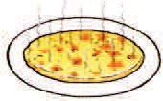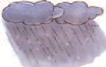

**Example:** The *dalia* is too hot to eat.

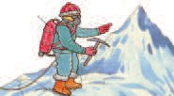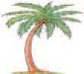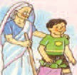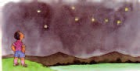

###### Look at the use of 's or s' in the sentences. 's is used for possessive. 's is used for singular number and s' is used for plural indications.

**Example:**

* 1. This is my **brother's** pen.
  2. He wears his **brother's** shirt.
  3. The **girls'** garments are very cheap in this shop.

###### Rewrite the sentences with 's or s'.

1. He sat on a chair that his grandfather used.
2. The Prime Minister inaugurated the hostel for girls.
3. What is the real name of the Golden girl ?
4. The school invited the grandparents of all students to the annual function.
5. I am looking for the stick that my grandmother uses for walking.

### Writing

Dear Diary....

###### Imagine that last year your school team took a 'Bastar Special' package tour to visit Bastar. Write a brief description of the first two days of your tour giving the following information.

* 1. Where did you stay?
  2. When and where did the tour start?
  3. What places/sites did you visit?
  4. When and where did you eat?
  5. Did you see any cultural programme?
  6. What things did you buy?

### Activity

###### Listen to the passage and answer the questions.

*See Appendix 1* Lesson 18.

* 1. Where did the stag see his own reflection ?
  2. Which parts of his body did he not like ?
  3. Which parts of his body got the stag into trouble?
  4. Why couldn't the stag escape?
  5. What did the stag think at last?
  6. Give a suitable title to the passage.

###### Work in pairs.

**Given below are two columns. Choose the things from the columns and complete the conversation.**

**Example:** Would you like to be a tourist guide?

Yes, because I like to visit places.

|  |  |  |
| --- | --- | --- |
| to be |  | because |
| tourist guide traveller cameraman dancer sailor  pilot  train driver mountaineer | Yes/No |  |

***English-7***

### Project

###### Maintain a diary.

1. **Book Worm**
   1. Take a white drawing sheet as shown.
   2. Cut as shown in the picture.
   3. Draw eyes and the lines on its body.
   4. Fix two small black strands of woollen threads as shown.



From Tomorow on

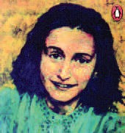

*How can we stay cool in difficult times? Discuss.*

From tomorrow on I shall be sad, From tomorrow on.

Not today, today I shall be glad.

And everyday, no matter how bitter it may be, I shall say :

From tomorrow on I shall be sad, Not today.

**19. From Tomorrow on**

### Word Meanings

glad happy

Anne Frank

***Translation - Joseph Leftwich***

bitter fact or event that is difficult to accept.

sad unhappy

### Reading comprehension

###### Answer the following questions.

1. When will the child become sad ? (Answer in one word)
2. What does she want to be today ?
3. “From tomorrow on I shall be sad” -

What does the child mean when she says so ?

### Vocabulary

###### Look at the pictures given below and fill in the blanks with the related words :

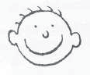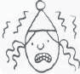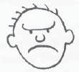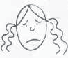

I feel when I’ve done something well. People hurting each other makes me feel . My friend is of big dogs.

I get when I am asked to sing a song on the stage.

***English-7***

###### Here are some words given in the box. Make sentences using these words. The first one is done for you.

**happy, angry, sad, frightened, surprised Example :** When I stood first in the class, I felt very happy.

### Activity

###### Recite the following poem in groups and enjoy.

I wish Today were yesterday

I do not care, I did not care, I will not care tomorrow

I only want to laugh and play- Now hear my tale of sorrow.

I did not care, I would not care. For breakfast, lunch or dinner,

Instead I stuffed myself with snacks, I wish that I were thinner.

A year ago of yesterday,

I lived quite free of sorrow, I wish today were yesterday and yesterday tomorrow.

### Project

###### Fill in the blanks with correct rhyming words and complete the poem.

Do the sums, do the sums

are the words of our 1 Do them now, right now

For I know not 2

As tomorrow never comes

So do them 3 right 3 .

Whether in colonies or in 4

The common word of our 1

Do the sums, do the sums. Clues : 1. Short form of mummy.

* 1. Short form of tomorrow.
  2. Rearrange w, n, o to get the word.
  3. Poor people live here.

Unfriendly Nature

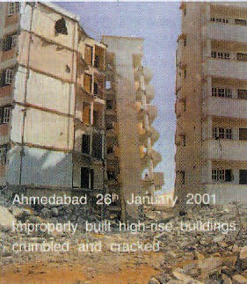

*Have you ever experienced an earthquake?*

Natural disasters are sudden changes in the environment, which cause damage and destruction. These include earthquakes, droughts, land slides and cyclones.

**When The Earth Shook**

**28th Jan., 2001**

More than 13,000 people were killed, at least 15 lakh injured and

7.8 lakh houses destroyed in Gujarat in the earthquake of 26th Jan, 2001.

**20. Unfriendly Nature**

An earthquake is a series of shocks that results from sudden movements below the surface of the earth. Earthquakes take place when large plates of land collide with each other releasing energy. The strength of an earthquake is measured using a Richter scale by an instrument called Seismograph.

*What should you do for your safety during an earthquake?*

|  |  |
| --- | --- |
| **Do ()** | **Don't do ( X )** |
| Bend down under a desk or cot, stay there till the shocks stop. | Do not push others or stand under fans. |
| Stay away from glass windows. | Don't use the lift in big buildings. |
| Outside, move away from trees, signboards, buildings and electric poles and stop driving during tremors. | Don't light fires.  Don't rush out of stadiums.  Don't travel just after an earth- quake. |

***English-7***

**June 7, 2002**

# Indians Flee Monsoon Floods

Parts of Assam and the neighbouring state of Arunachal Pradesh remain cut-off from the rest of the country, as flooding waters have destroyed transport

links. Flood affects Northeast India every year. In August 2000, floods killed 100 people and left 70,000 people homeless in Assam alone.

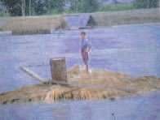A flood occurs when water flows or rises above its normal level. It can be caused by heavy rainfall, high tide with a storm or melting snow flowing into the river. The Ganga and the Brahmaputra rivers cause the largest floods in India. Other areas in the west, east and south are also attacked by floods. Floods are the results of soil erosion, the silting of riverbeds or collapse of a dam.

*What should you do if heavy rains cause flood in your area?*

|  |  |
| --- | --- |
| **Do ()** | **Don't do ( X )** |
| Know the route to the nearest safe shelters.  Keep medicines, strong ropes, radio, torch, batteries.  Store clothes, dry food, fresh water, kerosene, candles and match boxes in polythene bags in a kit.  Listen to the local radio and watch TV for warnings.  Drink boiled water. | Don't eat food that has got wet in flood waters.  Do not remain on empty stomach. Do not get into water of unknown depth and current.  Do not drink tapwater without boiling. |

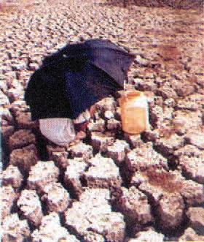Unfriendly Nature

indirectly affects

all people.

or

directly

in

and

September

waiting

drought

The

between July and

don't have money

to buy even food.

period

the

Rajasthan, spend

villagers

The

praying for rains.

year,

near

in

26th Nov., 2000

Every villages Bikaner

**Drought Affects**

Drought happens when an area receives lesser rainfall than normal levels. It is a condition of acute scarcity of water,

food, fodder and employment. The serious results of drought are crop-failure and lack of drinking water.

*What can you do to fight serious results of drought?*

|  |  |
| --- | --- |
| **Do ()** | **Don't do ( X )** |
| Grow plants and care for them.  Protect and restore degraded land  Collect and store rain water | Don't misuse or waste water.  Don't destroy forests, pastures and trees.  Don't let domestic animals overgraze. |

### Word Meanings

- Newspaper Clipping

tremor a slight shaking movement of the earth violent shocks great shaking caused by an earthquake

collide to hit something or someone that is moving in a different direction from you

tremble to shake uncontrolably

seismograph an instrument that measures and records the movement of the earth during an earthquake

soil erosion process of soil being gradually destroyed by rain, wind, the sea etc.

***English-7***

sand, mud, soil etc. that settles in the bed of a

river

get disconnected, separated from other places

to make something return to its previous condition. a situation or condition of something made worse food for cattle

situation in which there is not enough of something state of crop not growing due to lack of water

to let animals eat grass from the same piece of

land

silting of river beds

get cut-off restore degraded fodder scarcity crop failure overgraze

### Reading Comprehension

###### Complete the table with the help of the information in the lesson.

|  |  |  |  |
| --- | --- | --- | --- |
|  | DISASTER | CONDITIONS | RESULTS |
| 1. | Earthquake | large plates of | violent shocks, |
|  |  | ........................ | release of energy |
| 2. | .................... | using lift in big buildings | could be dangerous. |
| 3. | Flood | heavy rainfall | results in.............. |
|  |  |  | ............................. |
| 4. | Drought | less.......................... | acute scarcity of |
|  |  |  | water, food and fodder. |
| 5 | Flood | using......................... | cholera and dysentry in |
|  |  | ................................. | people especially, |
|  |  |  | children. |

1. **Write phrases or words to tell how the following are affected during natural calamities.**

*One is done for you.*

become homeless

people and cattle die

Flood trees

canals & wells

houses

**104**

Unfriendly Nature

die

cattle do not get.............

Drought wells ponds

fields crops

Earthquake people cattle building

electric poles

|  |  |
| --- | --- |
| **3. State True or False.** |  |
| (i) The earthquake in Gujarat in 2001 killed 13,000 people. | ( ) |
| (ii) We should run out of homes as soon as we feel tremors. | ( ) |
| (iii) We should bend down under cots and desks during floods. | ( ) |
| (iv) 70,000 people became homeless in Assam due to earthquake. | ( ) |
| (v) Eating food that has got wet in flood water is harmful. | ( ) |
| (vi) The local radio warns us about earthquakes and floods. | ( ) |
| (vii)People in Bikaner always enjoy rains. | ( ) |
| (viii) The villagers become poor and unemployed due to drought. | ( ) |

### Vocabulary

###### Tick () the word that is not related to those written in capitals.

earth patient hand wind

TREMORS

***English-7***

weather months

VIOLENT

SCARCITY

sea tree quarrel

labour water food

land river health

RESTORE

wealth

### Grammar

###### Write your sentences using 'must'. What could you suggest in the following

**situations?**

**Example is given for you.**

**Example:** I worked hard today. I feel tired now.

You must take rest now.

1. My mother will get angry. I am getting late.
2. I have a headache. I can't work now.
3. She wants to be a singer in future. She doesn't sing very well now.
4. She is a very naughty girl. She doesn't obey elders.
5. My younger brother is looking for a good job. He has no job now.
6. My handwriting is very poor. I feel it.

### Writing

###### Write slogans on "Disaster Awareness" on sheets of coloured paper to display in your class.

***Activity***

1. **Listen to the story carefully and fill the columns of the table given below to match with the describing words. One is done for you.**

*See Appendix 1,* Lesson 20

|  |  |  |
| --- | --- | --- |
| **Persons** | **Things** | **Describing words** |
| A wood cutter and his wife. |  | old and poor |
| forest | thick and deep |
|  | tired and thirsty |
|  | cold and sweet |
|  | young and handsome |
|  | happily |

Unfriendly Nature

|  |  |  |
| --- | --- | --- |
| A wood cutter and his wife. |  | little |
|  | tall, green |
|  | surprised |
|  | helpless |
|  | clear |
|  | sad |

###### Tick the correct answer for the questions asked as you listen to the story a second time.

* 1. near a pond, near a forest, near a park
  2. hot and tired, tired and hungry, tired and thirsty
  3. his wife's face, a different face, a happy face

### Project

###### Look at the maps carefully and write the cards.

1. The states where there is a danger of earthquakes.
2. The states generally affected by floods.
3. The rivers that generally cause floods.
4. The states that face droughts.
5. States that are likely to face drought and flood both.
6. States where earthquakes and flood both can happen.

**Example:** The states where there is a danger of earthquakes are Gujarat, Rajasthan, Uttar Pradesh and .......................... .



**21. The Great Sculler**

*Who is a good sports person ? Discuss.*

The great sculler and his son Bobby row down the river.

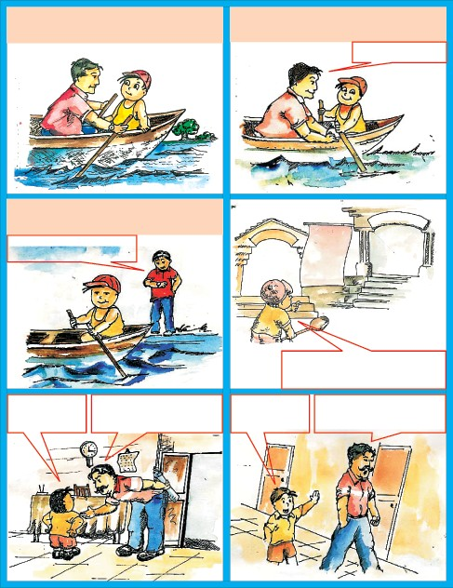

Five year old Bobby was often seen sculling through.

Great sculling my boy! Good speed. Keep it up.

Bobby admires his father and wants to copy him.

Hold it like this, son.

**NOTICE GREAT CAFE**

**For Fourteen year old scullers contest on 7 November at Sunday.**

I want to take part but

I am only six years old. I shall go and talk to the chairman.

I want to take part in the competition.

***English-7***

Sorry. That’s not possible. The contest is for 14 year olds.

Sir, I can do it. please sir...

Ok. Ok. Go ahead and don’t bother me.

The Great Sculler

###### SCULLING CLUB

Thank you very much sir. You will be proud of me sir. I promise you.

The great day arrives. Bobby is well prepared.

He does very well and finally....

Bobby! Bobby!

Bobby!

He is the Youngest one

Great!

Bobby Pearce has won the gold medal.

Yea

hurrah Can’t believe

it!

When Bobby was twenty Bobby

races for the Olympic gold.

At twenty one, Bobby is ready to take part in the Olympics at Amsterdam.

Bobby is leading. Ken Meyers is just behind Bobby. The crowd is very excited

Bobby!

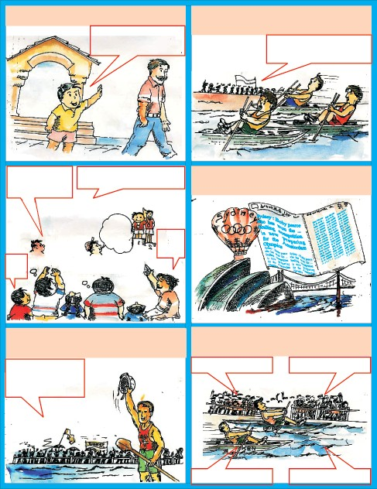

Bobby!

Bobby!

Go Bobby go.

Keep it up.

Bobby is leading.

Buck up Bobby.

***English-7***

###### But suddenly, Bobby hears a sound : quack-quack........

**The crowd is mad.**

Oh! A brood of ducklings is coming in my course. I must not hurt them. I must slow down.

He is slowing down. What is wrong?

Go. Go.

Bobby, don’t stop or you will lose.

Oh! No.

? ? ? ? ?

###### Bobby waits for the ducks to cross Then......

Ken Mayers will win. Bobby will lose the gold.

###### Now again he picks up speed.

Ken Mayers is here. He is just ahead me. I can pick up speed now because the ducks have crossed.

Bobby is great. He has saved the ducks.

Bobby is very nice. He saved the ducks.

Wow! He is still leading.

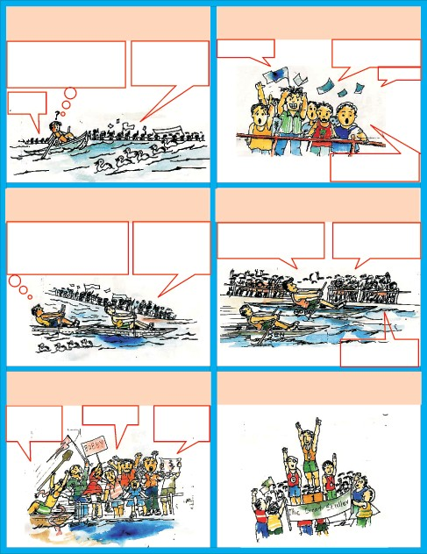

He has done it.

Buck up Bobby.

###### Finally.............. Bobby Pearce wins the race.......

Hurrah! Bobby!

Bobby!

Bobby!

The Great Sculler

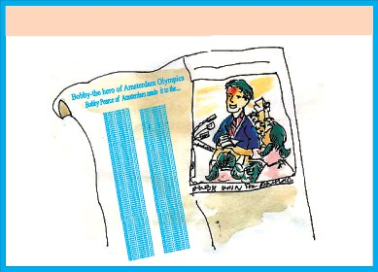

**..... and also the hearts of millions of people.**

### Word Meanings

- Writers Group

to get ready for something

to think highly of somebody to reach

the number 10,00,000

a competition to find the best from a competition competition

last, happening at the end

prepare

admire arrive million

championship contest

final

***Reading Comprehension***

1. **Against each sentence given below, write ‘T’(true), ‘F’(false) or ‘DK’ (don’t know). Write ‘DK’ if the lesson does not tell you whether it is true of false:**

|  |  |
| --- | --- |
| 1. Bobby Pearce’s father was a sculler. | ( ) |
| 2. Bobby started sculling at a young age. | ( ) |
| 3. Bobby’s father asked him to take part  in the contest for fourteen year olds. | ( ) |
| 4. When he was a 5 year old boy, Bobby | ( ) |
| competed with fourteen year olds.  5. Bobby Pearce won only one Olympic medal. | ( ) |
| 6. Bobby’s father was a good sculler. | ( ) |

***English-7***

1. **Answer the following questions.**
   1. At the sculling club Bobby made a promise. Did he keep it?
   2. Do you find anything uncommon in Bobby as a sports man? What is it?
   3. Who was sculling just behind Bobby Pearce?
   4. “Bobby Pearce won the race and also the hearts of millions of people.” Does every one who wins a race not win the hearts of people? Give your opinion.
   5. From the words given below pick up the ones that people said when he did well.
      1. Oh no! 2. Buck up! 3. Well done!

4. He has done it! 5. Hurrah!

* 1. Pick up words from the text that people said when Bobby was slowing down.

### Grammar

###### Work in pairs . Practice the dialogues with your friend and answer as given in the example:

**Ask a question from the table :**

|  |  |  |  |
| --- | --- | --- | --- |
|  | ridden climbed been gone | a buffalo  a coconut tree  the Danteshwari temple to school |  |
| Have you ever  **Answer** | flown sat played put on made rowed  Yes, I have.  No, I haven’t | an aeroplane  in the Principal’s chair in the rain  your father’s shoes  *jalebis*  a boat | ? |

**Ask the question :**

When did you do it?

**Answer -** I did yesterday/previous day/last year/last month/week etc.

The Great Sculler

### Vocabulary

###### Puzzle:

R V N S P T S

L E Z D R A A O P I C K U P W L Q B R N O D G E T U P L O S T G J H F W C A R R Y O N

B U C K U P

###### From the puzzle given above find words which mean:

1. continue, do not stop
2. make the speed less
3. wake from sleep
4. making the speed better
5. any other meaningful word you can find

### Writing

1. Guess what mother duck said to her ducklings when she saw Bobby Pearce coming towards them. Write your guess in the speech bubble.

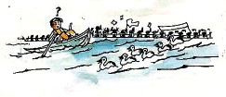

1. The brood of ducks have come ashore safely. What could have the ducks been saying? Guess and write in the speech bubble.

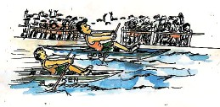

**113**

***English-7***

1. Write the incident of Bobby Pearce and the ducks in your own words (Hint: Bobby takes part, leads, slows down, picks up speed, saves the ducks)

### Activity

###### You watch cricket matches on the television. They show you the score board. Listen to this cricket commentry and identify the person being talked about. Write the number of the description in the empty box beside the score card as you hear them.

*See Appendix 1* lesson 21.

###### Score Card

|  |  |  |  |  |  |  |
| --- | --- | --- | --- | --- | --- | --- |
|  | **Bowling** | **Overs** | **Maidens** | **Runs** | **Wickets** | **Description no.** |
| 1. | Manjeet | 3.3 | 1 | 22 | 4 |  |
| 2. | Sunil | 4 | 0 | 28 | 3 |
| 3. | Anwar | 4 | 1 | 16 | 0 |
| 4. | Amarjit | 4 | 0 | 21 | 2 |
| 5. | Joshi | 4 | 1 | 25 | 4 |

1. **Tell the class about the activities you did yesterday and what you would do today.**

An example is given below.

**Example:** I ate *poha* yesterday at breakfast. Today, I will eat *samosas*.

###### Present a skit based on the story of the great sculler. While presenting the skit remember to give due importance to:

* + the emotion and mood of the place
  + facial expressions, actions
  + voice modulation, pauses, pronunciation

### Project

###### Make a list of well known players in :

(A) your school (B) your state

**114**

Appendix-I

**Appendix - I**

**Listening Passages**

###### Lesson 7 - Jimmy Jet and his TV Set

Vishu - Do you like watching TV ?

Vinni - Yes, I do. I like Cartoon Network and Pogo channel.

Vishu - But I like Discovery channel and National-Geographic channel.

Vini - Oh ! no ! --.

Vishu - They show real life scenes.

Vinni - But I like fantasies. My grandmother is always after Aastha and Sanskar channel.

Vishu - And my parents you know, they only want to see News and Samachar, Samachar and News and nothing else.

Vinni - Oh ! my sister Sheena, just  years old, always eager to see music channels only. She doesn't understand anything else I think.

Vishu - No ! I feel it is because. may be she likes dance.

Vinni - But we aren't able to see our favourite channels.

###### Lesson 8 - A Serious Talk

**(A)** My name is Anopheles. I am a female mosquito. I am one kind among more than 1400 types of mosquitoes. I have a slender, tube-shaped body, three pairs of long legs, and two narrow wings. My special needle-shaped mouth- parts can pierce the human skin easily. I love to bite humans and animals to suck their blood. When I bite a victim, I inject a secret substance that makes the blood flow more easily. My home is on or near still water.

I enjoy damp and humid places, especially the muddy water which collect in swamps, ponds and in ditches. Pools or dirty water from kitchens and

***English-7***

bathrooms make good homes for us. I specialise in causing a serious disease called malaria.

###### Lesson 9 - Have a Cup of Nice Tea

A 1. In a class of 100 students, 70 like tea, 5 like milk, 10 like coffee and 15 students like lassi.

Out of 60 girl students 40 like tea, 5 like coffee, 10 like lassi and 5 girls like milk

###### Lesson 10 - Our Little River

Onam is the most popular festival of Kerala. It is celebrated in August or September. People get up early in the morning and take bath and wear new clothes. Girls make colourful designs with flowers in front of their houses. There are boat races and other games on the last day of Onam.

###### Lesson 11 - Grandchildren by Surprise

Greg Smith is a small boy with a huge IQ and even bigger heart. Before he was two, Greg could name all the dinosaurs that ever lived. At the age of nine, he passed high school with honours, and in May 2003, at the age of 13, he graduated from Randalph - Macon college in Virgina. Greg uses his free time to help children whose lives have been scarred by violence & poverty. The same year he was nominated as the youngest person for the Nobel Peace Prize.

###### Lesson 12 - The Chinese—Our Neighbour

Snow Festival - It is a festival of Japan celebrated in the month of February. At the Snow Festival people make statues from snow. Some of the statues are very big. You can just look at the statues - or you can make one yourself.

Carnival - It is a celebration of Brazil, held in February. People celebrate Carnival in many countries, but the best known is in Brazil. In Rio-de-Janerio, many thousands of people parade through the streets. They wear fantastic costumes and dance to Samba music.

Appendix-I

Holi - It is a festival of India celebrated in March. On this day people play with colours.

Songkran - It is a festival of Thailand celebrated in April. On this day, everyone throws water at everyone else. The people have to roll up their car windows to avoid being sprinkled with water. It is also called the Water Festival. It is actually the Thai New Year celebration.

###### Lesson 14 - The Angel of Peace

Mother Teresa was born on 27th August 1910 at Skopje Yugoslavia . She was called Agnes. At the age of 18, she left home to become a nun. After training, she was sent to Kolkata. There she taught at a convent high school as a Geogra- phy teacher and later became its principal.

She was honoured all over the world for her humanitarian work. She was awarded the Padmashree in 1962, International Pope John XXIII peace prize in 1971, Nobel Peace prize in 1979, Bharat-Ratna in 1980 and many other Na- tional and International awards.

She was one of the few people given a pass by the Indian Railways to travel free wherever she liked. Apart from India, her humanitarian work ex- panded into countries like America, U.K., Tanzania and Venezuela. A volunteer who worked with her said, “Mother Teresa sees God in us all.” Mother passed away on 5th September 1997.

###### Lesson 15 - The Glorious Whitewasher

1. Meenu is 10 years old. She is naughty and loves to play at the sea-shore.
2. Pratap is 22 years old. He is preparing for competitive examinations.
3. Mrs. Joseph is a retired teacher. She is planning to get all her poems published.
4. Nikki thinks that her grand mother makes the best sweaters in the world.
5. Vinod loves to wear clothes like the heroes in films.
6. Asif is always ready to make people laugh.

***English-7***

1. Aruna wants to learn more about Hindustani Music.
2. Binu is now the fastest bowler in his school.

###### Lesson 16 - Half–way down

1. You board trains here.
2. Fruits, vegetables and grains are sold once a week here.
3. This place is meant for treatment of patients.
4. You can send your parcels from here.
5. Children play here in the evenings and during holidays.
6. You can make phone calls from this place.

###### Lesson 17 - Making Best Out of Waste, Her Forte

1. Tear the colourful waste paper into little bits.
2. Draw a big fish on the white sheet.
3. Spread gum on the fish.
4. Spread the wool yarn and paper bits on the fish drawn by you.
5. Press the fish and dry it up.

###### Lesson 18 - Dear Diary.......

Once a stag saw his reflection standing beside a pond. He thought of his horns. "How beautiful are my horns" said the stag to himself. But when he saw his legs he thought "I wish my legs were as beautiful as my horns."

One day he was chased by hunters and dogs. His long and ugly legs helped him to run fast and escape. But his horns were caught in the branches of a thorny bush. The stag tried very hard but he failed. He began to think; "My long and ugly legs helped me to run fast, but my beautiful horns got me into this trouble."

###### Lesson 20 -Unfriendly Nature

Long-long ago there lived an old and poor wood cutter with his wife. They lived near a thick forest. The wood cutter went to the forest to cut wood.

Appendix-I

One day, as the wood cutter went into the deep forest, he felt very tired and thirsty. He searched for water. At last he saw a pond. The water of that pond was very cold and sweet. The wood cutter drank it.

Suddenly, he looked at himself in the cool water of the pond. He was surprised. His face looked different. He was young and handsome now. He went happily to his home and told his wife about the pond.

Next day his wife went to that pond and drank and drank and drank the cold and sweet water. She did not return home. The wood cutter was worried. He ran into the deep forest and reached the pond. His wife was nowhere. Instead, a little baby was crying in the tall green grass.

The wood cutter lifted the helpless baby in his arms with great-sorrow and carried her home. The little baby was his wife.

###### Answer the following questions.

* 1. Where did the wood cutter live?
  2. How did the wood cutter feel in the forest?
  3. What did he see in the pond water?

###### Lesson-21 The Great Sculler

Last Sunday we saw a 20-20 match between Class VI and Class VII of the Inter Class Cricket Tournament of our school.

1. He bowled 4 overs, took the wickets of Rakesh, Vinod, Peter and gave away 28 runs.
2. In 4 overs that he bowled, he took the wickets of Anil, Rajendra, Manjeet and Saurav, giving away 25 runs.
3. He took four wickets, bowled a maiden over and gave away 22 runs.
4. The two wickets he took were of Abhay and Wasan and gave away 21 runs in 4 overs.
5. He could not succeed in taking any wicket but gave away only 16 runs in 4 overs, out of which one was a maiden over.

***English-7***

**Appendix - II**

**About the Lessons**

###### Lesson 1 : Hobble-Bobble :

This is a funny poem taken from ‘The Singing Grammar’. It has a few familiar verbs that have been used in an amusing way. Children are expected to comprehend it correctly and enjoy the poem. Reading the poem properly would make it all the more enjoyable.

###### Lesson 2 : The Missing Whistle :

This is a fun-story with animal characters. It is an interesting nar- ration about a piglet who tried to help his friend rabbit to search a whistle that he had lost. The story is taken from the ‘Pooh’s Green Book of Little Stories’ Children would find it an interesting piece of reading.

###### Lesson 3 : Handcare :

This lesson is based on a poster. The language used in the poster is presented in an interesting way. The children get familiarised with the patterns of the language. While the children enjoy read- ing the poster, they learn suggestable ways of developing good hygienic habits.

###### Lesson 4 : Hard to Believe :

The lesson has a few amazing extracts from Ripley’s 'Believe It or Not'. It is an attempt to make reading interesting and informa- tive. It is expected that learners would be motivated to read the lesson and comprehend the facts themselves.

###### Lesson 5 : Alice in Wonderland-II

The lesson is a continuation of the dreamland story of Alice, an adaptation from the famous story by Lewis Carroll. The lesson aims at enhancing children’s imagination and curiosity while they read about Alice.

Appendix-II

###### Lesson 6 : Union is Strength

The lessons is taken from ‘Panchtantra's Story'. The story is just to read and revise the vocabolary and sentence structures. The learners will enjoy the language and develop the reading habit for beyond the text book.

###### Lesson 7 : Jimmy Jet and His TV Set :

The poem is an interesting and enjoyable presentation about the fate of a child who loves watching the television. Children would be able to identify themselves with the character Jimmy Jet and the poem will amuse them.

###### Lesson 8 : A Serious Talk :

The lesson presents an interesting dialogue between a fly and a spider in the comic style. It is not only an attempt to introduce children to modern home appliances like a vacuum-cleaner, but also an amusing way to know about the happenings in the insect world. The insects realise that they can never become friends and they can never change their nature.

###### Lesson 9 : Have a Cup of Nice Tea :

This is an autobiography of the popular beverage ‘tea’. It is ex- pected that children would learn new ways of using language in creative expressions. The lesson also provides more information about 'Tea'.

###### Lesson 10 : Our Little River :

The poem ‘Our Little River’ is well known poem by Rabindranath Tagore. Originally the poem is known as 'Nadi' that appeared in 1896 in book form; later on it was included in ‘Shishu paath’. The poem is translated by Sukhendu Ray and Sukanta Chaudhari.

The poem is the vivid description of the natural surroundigs and the village scene – the day life of the village situated by the riverside.

###### Lesson 11 : Grand Children by Surprise :

The lesson is an adaptation of the story by Jane Flory. The story depicts a vivid picture of the love and family kinship needed in old age. It also tells how important children are for a home.

***English-7***

###### Lesson 12 : The Chinese-Our Neighbour :

An adaptation of an article- ‘The Chinese-Sons of Han,’ published in the ‘Target’ (magazine). The lesson describes the social tradi- tions, fairs and festivals in China. Children would love to read how a boy feels proud to be a part of the Chinese culture and heritage and how it is similar to our own culture. It is an inclusion under international relationship with our neighbouring countries.

###### Lesson 13 : Only God can Make a Tree :

This poem by Joyce Kilmer is a beautiful description of a tree that is so much like a mother. The poet gives a lovely and symbolic account of the nature and remarks that such a creation can be made only by God.

###### Lesson 14 : The Angel of Peace :

Mother Teresa is a name known to almost all Indians and to peo- ple all over the world. She spent all her life working for the poor, the sick and the uncared. She began her mission with 'Nirmal Hriday' and was full of love and kindness for mankind.

###### Lesson 15 : The Glorious Whitewasher :

The lesson is an extract from the famous book **“**The Advetures of Tom Sawyer” by Mark Twain. Tom, the main character is a naughty boy and had been troublesome at home. One day after playing and fighting with other boys he came late at night. His aunt saw his dirty clothes and decided to turn his Saturday into a day of hard work. At the end of the lesson Tom had turned his hard day into a good day. He enjoyed his day with his wit of managing the wrong things in the right way. (a real world of children.)

###### Lesson 16 : Half-way Down :

This poem by A.A. Milne is an experience of a child who loves to sit neither at the top nor at the bottom of a stair-case but wishes to be half the way. It is a strange wish but any child might enjoy doing so.

###### Lesson 17 : Making Best out of Waste her Forte :

The lesson is a report from a local newspaper that talks about the talent of a lady from Bhilai in our state. The extract infuses inspi- ration and creativity and also women empowerment.

Appendix-II

###### Lesson 18 : Dear Diary...

The lesson is an expression of a child’s account in her diary, about her visit to Bastar and other places. The description of places seen during the trip also includes the cheerful moments she spent with her relatives and family members.

###### Lesson 19 : From Tomorrow On :

This poem was written by a child named Anne Frank. It was origi- nally written in Yiddish language and later on was translated by Joseph Leftwich. Anne believed that people are really good at heart.

Anne frank was a bold girl. She was just in her teens, when the second world-war broke out. During the war Hitler ordered kill- ing of Jews in large numbers by sending them into gas chambers. Being a Jew, Anne’s family went into a hiding. They faced many difficulties. They had to remain inside the house. Still, she was hopeful. Even in that horrible atmosphere, she kept up the spirit to live every moment happily. Forgetting all the sorrow, Anne wrote her diary.

One day someone informed the army. The whole family, except her father was caught and killed. Later, her father found her diary and published it in 1947. People like reading it because Anne has described her experiences clearly and in a good humoured manner. This diary became popular all over the world. She wanted to become a film star. She could not: but her diary has made her a star indeed!

###### Lesson 20 : Unfriendly Nature :

The lesson is made up of newspaper clippings to induce aware- ness in children about natural calamities. It also aims at helping children with some technical knowledge about disasters.

###### Lesson 21 : The Great Sculler :

The comic strip is about Pearce, a great sculler, who won the Olympic rowing race. He was born in Sydney in Australia. His father was also a great sculling champion. A sculler is a person who rows with an oar in each hand.

The lesson describes a character from a real event at the Olympic games of 1928 in Amsterdam. Bobby Pearce not only won the gold medal but won the hearts of all who saw him win. The lesson has a moral value for children.

**LESSONWISE-SYLLABUS**

|  |  |  |  |  |  |  |  |  |  |  |  |
| --- | --- | --- | --- | --- | --- | --- | --- | --- | --- | --- | --- |
| **No.** | **Lesson** | **Form** | **L** | **S** | **R** | **W** | **Vocab** | **Grammatical items** | **Theme items** | **Language Functions** | **Project** |
| 1 | Hobble Bobble | Poem | - | - | **** | - | Phrases | - | Fun | - | - |
| 2 | The Missing Whistle | Picture Story | - | - | **** | - | Fill in the blanks | - | Fun | - | - |
| 3 | Hand Care | Poster | - | - | **** | - | Spelling | - | Health & Hygeine | - | - |
| 4 | Hard to Believe | Clipping Amazing News | - | - |  |  | Compounding Words  One Word  Substitution | - | World around us | - | - |
| 5 | Alice in Wonderland II | Story | - | - | **** | - | verb phrase | - | fantasy | - | - |
| 6. | Union is  Strength | Story | - | - | **** | - | word  expression | - | fable | - | - |
| 7 | Jimmy Jet and his TV set | Poem | Watching TV  Conversation | - | **** | note making | Homonyms Word Puzzle Word Web | - | fun | - | collect fun poems |
| 8 | A Serions Talk | conver  -sation | passage | conver- sation | **** | Letter writing informal | word expansion Riddle | If (unfulfilled condition) | EVS | Describing events | picture collection: insects and animals |

|  |  |  |  |  |  |  |  |  |  |  |  |
| --- | --- | --- | --- | --- | --- | --- | --- | --- | --- | --- | --- |
| **No.** | **Lesson** | **Form** | **L** | **S** | **R** | **W** | **Vocab** | **Grammatical items** | **Theme items** | **Language Functions** | **Project** |
| 9 | Have a Cup of Nice Tea | auto- biogrphy | passage | Expresing own view | **** | paragraph writing | Riddle | use of relative clause | EVS | Expresing liking and disliking | Collection of different leaves to  make file herbarium |
| 10 | Our Little River | Poem | passage | - | **** | paragraph writing Character Sketch | rhyming words  and fill in the blanks | - | Nature | - | making paper boat. |
| 11 | Grand children by Surprise | story | passage | Asking question | **** | notice writing | phrases Birtish, American spelling | as + Adj + as passive voice | family kinship | asking questions | picture collection of mssed up home |
| 12 | The Chinese our Neighbour | Descrip- tion | passage | framing questions | **** | composition writing | word formation | Compounding words | International understanding | Asking question | making 'kandeel' |
| 13 | Only God can Make a Tree | Poem | - | Role play | **** | paragraph writing | Rhyming Labelling | - | EVS | making request | Herbarium file |
| 14 | The Angel of Peace | Article | passage | picture discription | **** | paragraph writing | word puzzle words use in sentences | Narration (past simple) | Great personality | Describing people | picture collection of great personalities |

|  |  |  |  |  |  |  |  |  |  |  |  |
| --- | --- | --- | --- | --- | --- | --- | --- | --- | --- | --- | --- |
| **No.** | **Lesson** | **Form** | **L** | **S** | **R** | **W** | **Vocab** | **Grammatical items** | **Theme items** | **Language Functions** | **Project** |
| 15 | The Glorious White Washer | story | passage | Asking help and responding | **** | word list (Describing words) | opposite words | Gerund If  1st condition | Child psychology | Asking help | writing secret message |
| 16 | Half-way down | poem | map reading | Asking information | **** | - | kangaroo words (matching) | - | Child psychology | Asking information | Describing Places (pictures) |
| 17 | Making Best out of Waste her Forte | News paper Article | collage making | conversation | **** | punctuation sentencing  (story)  head lines | use words matching words, fill in  the blanks | verb forms passive (past  simple) | art and culture | Helping someone | making collage |
| 18 | Dear Diary | Diary | story | conversation | **** | description | word extend- ing puzzle, fill in the  blanks | Adverbial clause too-to  s’, ‘s | Culture and Heritage | Expressing liking | making Book mark  Diary Writing |
| 19 | From Tomorrow on | Poem | poetry | -  recitation | **** | - | picture matching, use the  words | - | life (optimistic view) | - | making poem |
| 20 | Unfriendly Nature | Article with news  clipping | story | map reading | **** | slogan writing | related words | must for (suggestions) | Nature and life (EVS) | seeking and telling information | collecting pictures and slogans |
| 21 | The Great Sculler | Comics | passage | Conversation | **** | dialogue writing | puzzle | 'ever', 'never' Present perfect | Sport | Asking questions | make a list of well  known players of your locality |